Welcome to a very special limited edition RWSAC newsletter, available only to those coming on the Weymouth plaice (and turbot) trip. It contains all the info you need for the trip.

Contact details
As most of you will know by now, we’re staying at the Sailor’s Return, which is on the quayside right alongside where the boats dock to pick us up. We’re booked in for two nights – Thursday the 29th and Friday the 30th, and we’re fishing on the Friday with Ken Leicester. If you want to have a chat with him about the fishing, you can call him on 01305 821040, but remember to be very, very polite.
The plan is to assemble in the pub as early as possible after work. Adam and I will probably get there about 9pm, but you get there any time, as long as it's not so late that everyone has gone to bed. Mind you, on Woody's usual performance, that would mean you wouldn’t be getting there till about half an hour after the boat has left in the morning. If you’re having problems finding the place or want to arrange a special blanket, you can call them on 01305 773377, and ask for Becky.
If you want to organise/scrounge a lift down there, call Adam on 01306 743744 (work) or 01273 478886 (home). If you need to speak to someone on the night because you’re delayed etc. call me on my mobile on 07798 625064. I’ve included a couple of maps to show you roughly where you’re heading for.

What gear?
We’ll probably be drifting all day over mussel beds after plaice. For this 12lb class gear would be best, though 20lb class stuff will do. Carp gear will be a bit on the light side for a big red spot on 80ft of water in a big tide over rough ground. We have got some spare stuff of the right calibre, so let us know what you need and we’ll bring it along.
We may well have a drift or two over the Shambles sand banks for turbot and brill. For this 20lb class gear is ideal, though 12lb class or 30lb class would also be okay. If you intend to fish light 12lb class gear, for god’s sake don’t mention it to Adam or he’ll bend you ear for hours about how stupid you are and how you’ll never land a decent-sized fish and you’re just asking for trouble and there’ll be no end of complications, and was it you who shot Archduke Ferdinand, and were you on the bridge of the Titanic that night?
You’ll need a variety of leads between 3oz and 12oz, depending on the tide and the diameter of line you’re using. For the plaice, 4/0 hooks are ideal, and you need 6/0s for turbot. I recommend a long-shanked, fine wire pattern such as an Aberdeen. This is ideal for mounting the ragworm (plaice) or sandeel (turbot) baits we’ll be using, and the wire ought to bend out of most snags if you get snarled up, so there’ll be less re-tackling.
A simple running leger with a long-ish flowing trace (6-10ft) is ideal for both sorts of fishing – the more the tide, the longer the hooklength. Most anglers use 5-8mm coloured beads on the hooklength as an attractor for plaice, and last year, all four plaice were taken on rigs which featured spoons of some sort. You’ll be able to buy anything you need along these lines in the Weymouth Angling Centre (01305 777771), which is just over the bridge from the pub. I’ve included some common rig variations that are often used for plaice below (though ignore the hook sizes, they’re too small).
See you there,
Ben

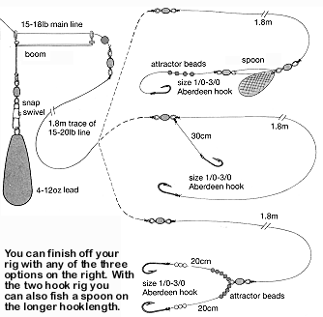

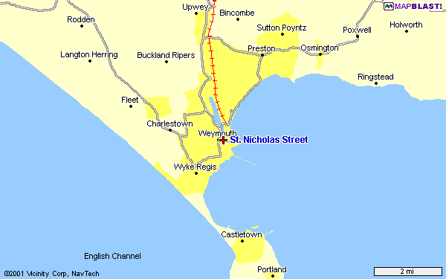
To the A35

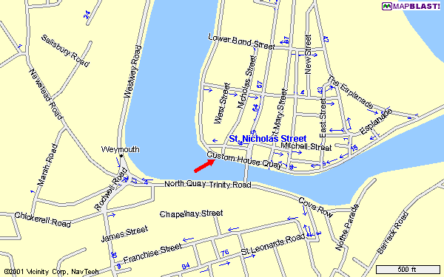
The Sailor’s Return is roughly where the big arrow is pointing

