So, normal service has been resumed. By this I am not referring to the fact that we have managed to get out fishing on no less than two occasions, as that is not normal service at all. At the risk of nominating myself for next year’s Steve Newham Trophy for Optimism and Cheer, normal service when it comes to fishing trips is to have every last one cancelled, apart from the one date that no-one can make.
No, the normal service I am referring to is Adam phoning me up every fifteen minutes to... oh hang, on that’s the phone, I’ll just tell him it’s in post... nag me about the newsletter. Lying there on his auto-recliner, supping ale and watching telly, pressing the redial button on his phone when he thinks I haven’t been reminded for two minutes. Still, I’m not bitter, the fat fucker.
But despite this, the year has started off rather well. The annual dinner was a great success, with high-tech wizardry and low-grade drunkenness and, as previously stated, we have actually been fishing. Long may it continue.

How do you hold this again?
With the dinner organised for the 20th of January, it seemed like a good idea to arrange a trip for the day before, to give us the opportunity to catch something special and then ruin everyone else’s evening by going on and on and on about it.
There was also the chance to fish for a new award – the Christmas Trophy – to be won by the person catching the biggest fish closest to Christmas. As we hadn’t been out as a club since late July, there was everything to fish for.
Sadly, with Lady Jane having her bottom scraped (which she’s quite keen on I understand), Chris couldn’t take us out, so we fell back on the trusty Larry Ryan. Now we haven’t always had the best of luck in winter with Larry, but that wouldn’t matter in any case, as with our run of luck, the trip was bound to be blown off.
Only it wasn’t. By some happy miracle, it was pretty much flat calm on the 19th of January as Timerlin and her five intrepid anglers set out for some rough ground to the East. We were in Timerlin because somebody had played chicken with a lighthouse while at the wheel of Larry’s first choice boat, Trinitas.
There was very little chit-chat as we cleared the breakwater, with most people trying to remember, after a six month lay-off, which way up to hold a rod, and how to tie on a hook. Even so, hopes were high that we’d be heaving out cod after cod, though no-one could quite remember what they looked like.
The weather was cold and still early on with lots of low cloud, and we were all very keen to get fishing just to warm up a bit. Down went the anchor over a bit of broken ground, down went the baits... There was a crackle of anticipation in the air, was that a bite? Dunno. May have been, couldn’t really say what a bite looks like.
Nope, that was definitely a rattle on Simon’s rod. And before you could say “bastard” a hard fighting pouting swung over the side. But that wasn’t all, and soon everyone in the boat was hauling in doggies and pout. We shall never see such sport again.
Then killjoy Larry put an end to our fun and had the anchor up, moving us a couple of miles further east. By now it was really cold and we battled through a white hell as blizzard conditions struck, in the form of a couple of snowflakes that settled gently on Adam’s sleeping form.
Having roused Frost from his slumber, the crew set about fishing, while Larry set about keeping us warm with his banter. That’s not to say that Larry is full of hot air. No, not at all. I for one was very interested to hear that Larry’s neighbour of a few years back, one Dick Walker, did not in fact catch Clarissa, the famous record carp, at Redmire Pool, but at another small lake that was known only to Larry and Dick. Indeed, had it not been for Larry putting Dick on to that swim and tipping him off about critically balanced bread, the history of fishing might have been very different...
This time Larry anchored us over a wreck, and the difference was immediately apparent, with, er, pouting and doggies coming thick and fast. As slack water approached, Two Dogs (Mick Deacon) had a devilishly cunning idea, which I can’t actually remember, but it worked, with a nice channel whiting breaking the run of pout. He followed this up with another, and soon most people were into one or two of them. In the absence of cod, they were most welcome.
As the tide started moving again, we swung off the wreck, but as we continued to catch quality pout, whiting and doggies no-one was that bothered. We had reached “The Bleak Zone” – the part of a not-great trip where everyone becomes Steve Newham and stops believing that the next bite will be from a big fish. But how wrong we were all were...
Oh, all right, how right we all were. We had sod all of any consequence all day, but it was very nice to get out and have some bites again after such a long time.
What tension there was durinf the afternoon was mainly provided by people trying to slip larger than average pouting back over the side without having them weighed, as Adam promised darkly that the Christmas Trophy was “a prize well worth winning”. In the end, this honour went to Two Dogs who landed a whiting which blotted out the sun, weighing nearly 2lb 8oz. And that was that. We all caught, but we missed out on cod. Ah well...

Dinner date from hell
The next day dawned cold and cloudy – a perfect day for charging around Lewes oin a panic trying to do and get all the things I’d forgotten about for the club dinner. Unimportant things, like engraving half the cups, my dinner suit, the Really Eely Tankard.
Luckily we found an engravers that was clearly grateful for the business, and though he was missing a few of the less common letters of the alphabet from his engraving kit, he was able to fill in most of the blanks on the trophies. Lucky also that Adam had a spare dinner suit back at his house, so that was okay, but there was nothing to be done about the Tankard. Oops.
I say “lucky” about the dinner suit, but when Adam pulled it out from its special storage space, crumpled up in a ball beneath a vast bag of leads and fish guts, it soon became clear that this was a dinner jacket that Adam had forcibly ripped off the back of a dwarf before using it to clean his car.
Luckily I’m only 6’ 3” so it fitted like a glove. Unfortunately, gloves don’t fit very well as jackets, so I looked less like a sophisticated James Bond figure and more of a hairy-arsed bag of Brooke Bond tea. Ironing it in vain attempt to get rid of the worst of the creases only served to shine up the material nicely. Still, it was dark at the dinner, so, apart from the smell of fish, I think I got away with it.
Once upstairs at the John Harvey restaurant, the trophy table groaned under the weight of the assembled silver- (and plastic-) ware. New trophies were kept under wraps, while previous awards were proudly displayed. From a distance, it almost looked like a proper set of club prizes.
Then the food arrived and we all tucked in, though some people were rather suspicious of the purple and brown objects that we were assured were “South African potatoes”, but which have since been identified as the source of the recent foot and mouth outbreak.
During the meal there was much merriment, with Chris Martin regaling us with tales of incredible stamina and strength that seemed to have little to do with fishing, and a lot more to do with his new French girlfriend. This may seem a bit far-fetched, but you didn’t see the way he was eyeing up the South African potatoes. Anyway, if anyone would like to get hold of any Viagra, Chris now gets a bulk discount direct from Pfitzer so he’s your man. (Sorry Chris, but you should never tell these sorts of things to the man who writes the newsletter).
Then it was time for the speeches and awards. Sadly between us we had not taken a single fish of more then half the national record weight in 1999, so there were no specimen medals to hand out, but there were medals for the glorious winners and pitiful losers of our Weymouth Species Hunt, and all the usual cups and medals. There’s a full list at the end of this newsletter if you want to see what you can aspire to.
The new awards included the Big Mouth Big Drink Singing Billy Bass award for the finest display of drinking by a club member. There were gasps of astonishment all round the tables as this was unexpectedly awarded to Jari Vanhatala. His achievement of drinking Weymouth dry of Sambucca on the last club trip was truly worthy of the prize.
Also new was the Breakfast Revisited Roll of Honour, a stunning trophy consisting of genuine plastic bacon, squeaking sausage and fake fried egg, lovingly hand-mounted on 100% real gold plate, itself afixed to a magnificent base of mahogony-effect bog seat by our master craftsmen.
This most desirable of prizes went to Matt Honeyball, who contrived to be so sick on day one of the main Weymouth trip that he fled rather than take to the seas on day two. Unfortunately Matt was unavailable for the dinner, as he had prior engagements shooting his latest film in the States. However, as you know, the Really Wrecked DAC is an extremely hi-tech organisation, and we manages to fix-up a satellite link for the ceremony. For those of you who weren’t there to see how your subs money is squandered, there’s a full transcript of our transatlantic conversation at the back of this newsletter.
Once Adam and I had finished slagging everyone off under the guise of giving out prizes, Mr. Colin Pearce stood and made a moving speech, before himself handing out an award which he called the Winnie Mandela Necklace Trophy for the best rig of the year. It was awarded without any hesitation to Mr. Adam Frost for the fantastic triple-spoon, double-wishbone tangling death trap that he inflicted on us during last year’s Weymouth plaice trip. There were other speeches, but sadly Mr Phil Boxall refused point blank to stand up and mutter as drunkenly and incoherently as he had the year before.
After that it was back to Adam’s for some delightful cocktails, some of which were so interesting I later re-examined them in great detail. To be honest I don’t remember much of that part of the evening, but I do have a vague memory of a feeling of enormous warmth and camaraderie to my fellow club members, so I must have been slaughtered.

Ayee! Arriba!
While the rest of us were freezing half to death in the aftermath of the dinner, three club members jetted off to the sunnier climes of Baja California to tackle sailfish, tuna, roosterfish and anything else they could find. It has proved hard to get the full facts about what happened on the trip, with Phil Boxall being particularly tight-lipped about the whole thing, but here are the few facts I managed to glean.
An excellent time was had by all, with much fishing and much tequila. Apparently Jari did not manage to drink all the cactus juice in North West Mexico, though by the end of the week they were having to bring it in from over a thousand miles away.
Phil hooked a sailfish and fought it for over an hour, twice bringing the magnificent beast to the side of the boat, only for it to scream off again in the general direction of Japan. Sadly the battle ended when the rubbing leader, frayed on the fish’s bill, parted when the sailfish went deep and refused to budge. But Beef was not too upset, having seen such a magnificent beast in action, and not having been responsible for its death.
Apparently Phil’s lovely Conoflex 15-30lb class rod stood up beautifully to the fight, and generally proved itself to be a gorgeous piece of craftsmanship. In other situations too, Phil’s rod proved worth its weight in gold, the action more than capable of handling an angry tuna, with plenty of power in reserve for when you needed it.
I know this because Phil managed to talk about his rod for two hours one evening without drawing breath. Adam has heard the same stories three times in excruciating detail. My advice to anyone hearing Phil start on about this is leave the pub straight away. And whatever you do, don’t let him get on to the subject of his Calcutta 700S. Don’t be fooled into thinking you can wait for him to exhaust himself, the man is tireless. You have been warned.
Plenty more fish were taken, mainly by Beef and Jari, much to Stevie’s increasing irritation. Indeed, on the last morning, with Stevie staring a very expensive six day blank in the face there was apparently a certain amount of rod-snatching and “That’s my fish, just you fuck off!” going on. As luck would have it, our Steve did manage to break his duck with only hours to go when he landed a mahe mahe, which a quick check of the Observer book of Mexican fishes confirms is the Mexican for pouting.
On the last night, an oil tanker laden with tequila put in to port, so there was just enough for Jari to have a quick drink before bedtime, while carousing with a troupe of Mexican ladyboys masquerading as dancers. Beef eventually ran out of steam and went to bed, only to be woken some time later by an ashen faced barman saying “your friend, he is sick”.
Jari, however, was not sick, he merely couldn’t walk, so Beef helped him upstairs, took off his cowboy boots and put him to bed. The next morning it turned out that Jari had somewhere in the region of six separate fractures in one of his legs. This is a fantastic effort by the Finn, particularly as it is the fourth limb he has broken in a six month period. Well done.
What was particularly odd is that there is no sign of any bruising on the shattered limb. The only theory which could possibly explain this, is that Beef managed to snap Jari’s leg like a dry twig while tugging at his boots. And the moral of all this? No matter how drunk you get, don’t let Phil take your boots off.
As a sad post script to the trip, Phil’s lovely Conoflex 15-30lb (has he told you about its action?) and Stevie’s wonderful Penn 12-20lb INXS are now in far too many pieces, having been crushed by over-enthusiastic baggage handlers en route. This, despite Phil carefully wrapping them both in tissue paper for the journey.
Two claims are currently with the respective insurance companies, Phil is claiming for a new Conoflex 15-30lb class rod, while Stevie has put down on his form six Penn rods, three Penn International 10/0s, two Charter Specials, five Calcuttas, as well as a rod specially built for him by Faberge two hundred years ago, and a unique reel by Patek Philippe.

What, another trip, so soon?
After countless cancellations before and after Christmas, we finally managed to get out for the first time with Stu Arnold aboard his lovely 40’ Lochin, Catchup III, on Friday the 16th of February. Unfortunately, being itself re-arranged from the Monday before, only eight of the ten anglers were able to make it, which meant that prices were £50 rather than the £40 for the day.
It was a real shame that flying-ace Steve Newham wasn’t there to cheer everyone up after I gave them this news, as with his impish grin and endless jokes, he certainly knows how to make you forget your troubles. Besides, knowing Steve, he’d have volunteered to cover the extra tenner a head himself in his usual philanthropic way. He’s just too generous for his own good.
With noted skinflints like Patrick Newman having to dig deeper into their triple padlocked wallets, the pressure to catch fish, already sky-high, was nearing bursting point. Could Stu do the business? Would we catch? Or would it be a deeply miserable bunch of bastards who made their way back in?
Pat certainly needed cheering up when he arrived, as the car he had stolen from a scrap heap in order to get to Eastbourne had exploded somewhere around Polegate, leaving him to push it the rest of the way. Another man who needed a good result was Paul Myles. Unusually Paul had not only managed to book a trip, but had somehow also managed to turn up, so it was imperative that he caught.
Eastbourne Marina may not have the drying out problems of Newhaven, but there is a lock which has to be negotiated. Once we were clear of that, we were off to the southwest in quite a hurry. It was a little sloppier than we might have hoped for, and the wind was forecast to pick up through the day, but we weren’t about to be deterred by a few white horses inside the marina, oh no.
We steamed out for about an hour, I think. It may have been longer but I was being entertained by Clive on the way out and I think I must have nodded off. We set up Redgilling gear – 18ft traces on flying collar gear, with medium-sized Redgills in black, orange, red and afterburner styles – and then most of the crew crammed in to the vast, warm cabin.

There’s always a snag
Once over the first wreck, we dropped our rigs, retrieved, dropped them, retrieved, dropped them, retrieved. And then wound in. This was repeated a couple of times, before a magnificent pouting came to the boat. Uh-oh, it was going to be one of those days. Despite the fact that there seemed to be plenty of fish showing on the fish finder, they didn’t seem to be hungry.
Then, joy of joys, on about the fourth drift, there was a proper take. I can’t remember who had it, but I’m sure whoever it was, he was deeply skilled in the ways of Izaac Walton, and a wily fisherman to boot. Or it may have been Two Dogs, I’m not too sure. It wasn’t a huge fish, perhaps six pounds, but it was a start.
However, it wasn’t followed by an avalanche of pollack, and we began to get the “You should have been here yesterday” feeling. A few drifts later, there was another smallish fish, and then a third, but it was pretty slow going.
On top of that, the wreck kept claiming Redgills, at least two set-ups per drift, and sometimes more. Stu said it was a very steep-sided wreck, but there may also have been wreck netting making life more difficult. It’s not great fun to have to tackle up once every couple of drifts, and there were more than a few black looks flashing around.
Stu suggested a move to another wreck a mile or so away, and we agreed, maybe the pollack would be a little more peckish there. And if that one didn’t produce, there was another further out which he would take us to.
On the second drift over the new wreck, two rods bent at once. Unusually for a Really Wrecked crew, this wasn’t followed by a sudden straightening of rods tips and many expletives. No, within a few minutes, two fat pollack lay beaten at the side of the boat – both in low double figures. Let’s have some more of that, please.
On the next drift we had one more of around the same size, and then another on the next. For the next half hour or so, we probably averaged about 1.1266543 fish per drift, with some decent specimens among them. And these fish were fit. All the way to the surface they battled, with the bigger ones taking off on several runs. This was fun.
Most of the fish were coming to single-coloured Redgills in red or black. For once, the Afterburners were looking distinctly fish-unfriendly.
On one drift, two especially plump pollack came to the boat, both of which looked like they might threaten Mr. Frost’s proudest record, which has stood at 15½lb for as long as anyone can remember. Not that he goes on and on about it, you understand, but there was a certain amount of keen anticipation on the boat when the first fish – mine by the way – went on the scales.
Damn and blast, it weighed in at around 14lb. Adam chuckled smugly into his foul, greasy beard. Then Clive’s fish was hung up for weighing. A hush fell on the boat. Stu eyed the needle in the rocking boat. He checked it once, then again, and pronounced the fish 15lb 14oz – fully 6oz better than the record. They could hear the cheers in France.
Adam muttered his congratulations too. Though no-one could hear the exact text of his speech, I think he mentioned something about a “ducking punt”. Presumably this was his way of saying what a great achievement it was to get the fish in while the boat was rolling so much on the swell.
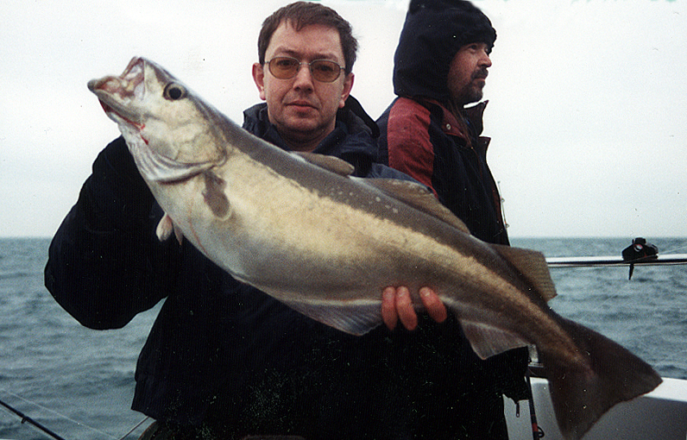
Clive and a beautiful, well-conditioned pollack of just under 16lb. Note that this picture has not been doctored.

As the tide slackened off, a couple of cod came to the boat, prompting the more bloodthirsty among the crew to abandon all vestige of civilisation and rig up their killer gear. Colin in particular lost all sense of where he was, stripping to the waist and smearing himself with pollack guts and the blood and excrement of a seagull he had caught and killed with his bare hands, all the while whooping and yelling strange Shona war cries.
However, these savage practices did pay off, with Colin and Two Dogs doing particularly well. Over the slack water period when very little was happening, these two had six or seven cod between them. Colin the Barbarian also managed to bag the best double-header we’ve had on a club trip, with two double-figure cod at once.

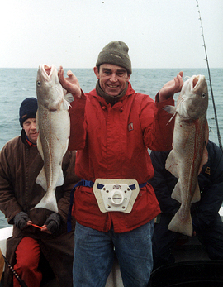
Colin’s magnificent brace of double-figure cod. He had just put on his jacket again for the photo.

Dear Roy Castle…
However, one of the anglers who remained true to the ‘gill was Paul Millmore. How much of this was due to his sporting instincts and how much to the fact that he was feeling a little too peaky to bother with changing rigs, I’m not at liberty to discuss, but suffice it to say that we have another addition to the Breakfast Revisted Roll of Honour, and our first two-time nominee.
One thing that might improve the situation for the poor fellow would be were he to wait until somehat later than half past six in the morning before indulging in his first herbal cigarette of the day. But I mention Paul for a better reason than just to plaster his evil and unnatural lusts all over the newsletter (and Internet too, just you wait). As he was steadily gilling away, without troubling the fish scorer too much, he suddenly bent into something that appeared to be rather big.
Now we, being a rough and uncouth bunch, merely assumed he was “Newhamming” the fish (making a tiny sprat seem like a 2000lb bluefin tuna), so we stood idly by, making jokes at the poor boy’s expense. Ignoring us, he bent into his task, manfully gaining line on the fish, which promptly took it back again. But yard by yard he drew it towards him, and eventually a rather respectable-looking cod was impaled by Stu on his magnificent golden gaff.
Just how respectable only became plain when Stu dumped it on the deck. “That’s well over twenty,” he said. “What did you say your record was, again?”
“Twenty two, Stu, quick weigh the bloody thing! That cod record has stood since the days when Eric the Red and the Venerable Bede stood shoulder to shoulder in the club coracle, slugging it out, coelacanth for coelacanth.”
On the scales it went. Up and down went the boat. We waited. The needle bounced. We waited. Then the verdict. “I reckon that’s at least 26lb, myself, maybe more.” Again the joy was unbounded aboard Catchup, though Paul was perhaps quieter than most, having put together another little number and was now celebrating by dozing gently in the corner. Aww, bless.
Paul’s fish and most of the other cod that fell to ‘gills rather than the “ripping” tactics employed by the Butcher of Dorking, came on orange lures. Many anglers have remarked on the effectiveness of orange for cod, and red and black for pollack, and so it proved on the day.
As the flood tide got under way a few last cod fell to ‘gills including Patrick Newman’s first ever – and therefore a PB – a nice fish in the 8-10lb range. Then the pollack came back on the feed, though this time, most came to Afterburners. It’s a funny old world. Again it was a good stamp of fish, averaging perhaps 8-10lb, though it was a measure of the fishing that we were secretly disappointed with them.

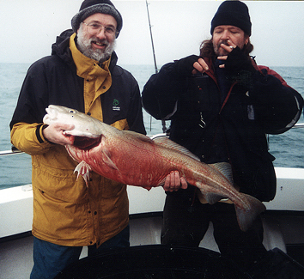
Paul Millmore gets to grips with the new clubs record cod, while Adam tries not to look jealous.

Then Two Dogs hit a decent-sized fish that lay doggo close to the bottom. It wasn’t tearing line off the reel like a pollack, nor was it nodding like a big fat cod. Various theories emerged. It was an anglerfish. It was a spider crab. It was the wreck. It was nothing at all, Mick’s flimsy £1.99-from-the-Oxfam-shop fibreglass rod from the 1960s was just bending under its own weight.
Eventually Two Dogs got whatever it was moving, and once it was nearer the surface it woke up and began dashing around like a fish possessed. We could see a shape in the water, but what was it? As it broke the surface, we were all mildly surprised to see it was a pollack, and a big one at that. The scales were called for, and in the end, the fish was given a minimum weight of 17lb, not a bad weight for a pollack from our end of the Channel.
Congratulations were again in order, though Adam could barely bring himself to grimace, and Clive, the pollack-record-holder-in-waiting, looked more than a little peeved as he accidentally kicked the fish into the fish box.
Two Dogs sent me a picture of his fish, along with the other pictures from the trip, which you see reproduced here in such tremendous quality it’s almost like you are there. But since I received the pics I have heard it said that one Mick Deacon was boasting in the pub that his hat had looked a little silly in the original pic and how he had doctored the picture to make sure he looked like less of a twat. If a man will stoop to such depths, who’s to say he won’t use electronic means to make his fish look bigger? I reproduce the picture here as he sent it to me so you can judge for yourself.
None of the rest of the fish taken came close to Mick’s in size, and all too soon, Stu was calling for the last drift of the day. But one man had not yet given up hope of recapturing his record. With a feverish glint in his eye, and twitching slightly, Adam Frost dropped down, praying to his unholy gods for a big pollack. Slowly he wound in... nothing. He dropped down again, and began his retrieve... not a sausage. Down, then up, down then up, then... bang! Off went a powerful fish with Adam’s redgill in its mouth.
Sensing this was special, Adam didn’t lunge into his usual half-strike/half-Stevie-snatching-a-tenner-from-the-fingers-of-an-OAP. Instead he gently coaxed the fish up from the depths, giving line when necessary and generally acting like he had a rough idea of what he was doing. He must have been watching the rest of us when he wasn’t sleeping.
The fish broke surface where Stu gaffed it for the quivering Frost. “That’s another big one,” said the skipper, eyeing the catch.
“Weigh it, weight it now!” whined Adam frenziedly, “Before any of the slime comes off and it loses weight.”
So Stu got out the scales and went through the ritual. Swing, swing, check, rock, roll, check, check. “I reckon that’s about 16lb. Definitely smaller.” That’s what the man said. I now reproduce in full Adams’ response to this.
“There. See? Just an ounce or two in it. Too close to tell really. It could be mine that’s bigger. The boat’s rolling much more now. What do you reckon Stu, about sixteen and seven eighths, eh? Could be seventeen and a half I reckon. Those scales are crap. They only weigh in quarts and dynes. You wanna get scales like mine. We’ll reweigh them in port where it’s nice and calm. I’ll just gut your fish now for you, shall I Mick?” Then he launched himself at Mick’s throat and started scrabbling around in the fish box weeping and slashing at pollack with his never-been-used gutting knife.
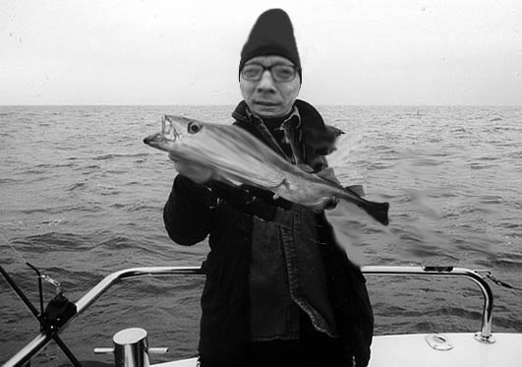
Two Dogs and the new record – but has this picture been tampered with?

We shall draw a veil over this undignified end to a fantastic day, and return to the boat as we steam in. A count of the fish revealed what a good day it had been – 28 pollack to 17lb, with at least half in double figures, and 12 cod to 26lb. Add to that two new records, and it was a very happy crew that headed back to Eastbourne.
Of course, some were happier than others. Adam still curses and reaches for a knife when you say the word pollack, whereas Paul Millmore was so delighted with his cod record that without bothering to go home and wash or change, he headed straight for fellow club-member Jonathan Barrett’s house, cod and all. Bursting in to a packed dinner party, the glassy-eyed angler slapped the cod down on the table, covering several of the guests in slime and roe and, beating his chest, roared “The record is mine!” before collapsing unconscious over the table.
Rumours that he then returned the next day to Jonathan’s house to show off his cod on three further occasions remain unconfirmed. However, I have it on very good authority that he has hired an open-topped bus and has been sighted in several Sussex towns parading the now-rotting fish like the FA cup to the bemused burghers. Police say you should treat this man with extreme caution if you see him, and do not attempt to tackle him.
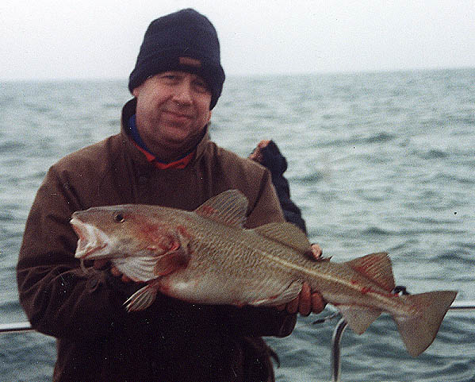

Paul and a decent cod. Smile you bastard!

Dates and notices
On the off-chance you’d like some more trips like that one, I’ve booked up a full complement for the next few months, with places available on most of them. Seeing how we’re booked up with some of the finest skippers in the land, I reckon you’d be mad not to get in there right now.
Monday March 12th There are ten places on Catchup III for this trip out with Stu Arnold from Eastbourne. The pollack will be really fat, so you never know, we might get a twenty.
Friday March 30th This year’s Weymouth plaice trip with Ken Leicester is fully booked, but to be a reserve, call Adam. For details see the last newsletter. What, you mean you don’t file them?
Monday 23rd April Our first trip out with Chris for ages, and on board Lady Jane too, so let’s get after those lovely wreck cod.
Wednesday 30th May An early conger or wreck cod trip with Stu on Catchup III. There may also be bream and pollack around.
Thursday 5th July The conger fishing should be in full swing by now, with black bream showing for the scaredy cats among you.
Friday 27th/Saturday 28th July There are still a few places left on the main Weymouth trip. We’ve got Richard English, Pat Carlin and Ken Leicester booked for all sorts of fishing, including blonde rays, bass, black bream, conger, tope, and the mighty corkwing. We stay three nights and fish a day inshore and a day offshore with these top skippers (with anchors and everything). Book now or regret it for the rest of your miserable existence.
Thursday 23rd August The chance of a really big bass on board Catchup III, one of the top bassing boats in the country.
Thursday 6th September This is prime time for massive conger, so who better than Chris to get us a long way off in Lady Jane after a ton-up eel?
Monday 24th September More bassing with Stu, so let’s catch us a double.
Monday 15th October The eels really feed now, as do the black bream, so if we don’t break both records on this trip with Chris, I’ll be amazed.
These trips are all partially booked already, so phone Adam as soon as you can. I think this year’s going to be a cracker, and I can’t wait to get out there again. If you’re interested in the March 12th trip, call him at home (01273 478886) on Thursday or Friday and leave a message if he’s not there. If you leave it any longer the boat will be filled. For the other trips, call him at home this week, or at work (01306 743744) next week, or email him on a.frost@ukintpress.com and he’ll try to fit you in.
Now, some of you may be cackling to yourselves that you’ve got away without paying your subs this year. Well don’t. I need the cash to pay for posting this gem of a newsletter, for deposits and to go some way to paying for all the magnificent awards we dish out every year. So stump up your fivers now. I’d also like £10 from everyone who books for either or both Weymouth trips. This is to cover the B&B and boat deposits and will be fully refunded when you come to pay for your room. People going on both trips do not need to give me £20, £10 will be fine.
And that’s it. After a terrible autumn, the year has got off to an excellent start, and with any luck it’ll get even better as the year progresses. So dig out your gear, and remember, even Paul Myles caught on the last trip, so it must be easy.
Tight lines,
Ben

