This special, limited-edition newsletter is only available to those committed anglers smart enough and keen enough to have booked up for the summer Weymouth trip. It’s full of useful information for the trip. The fact that all of you already know it all is irrelevant. You have signed up for the trip, and it is therefore your unpleasant duty to plough through this newsletter in the hope that there’ll be something you didn’t know amongst all the crap.

What are we fishing for?
We have two crews going down, as we have done for the last couple of years. Each will fish one day with Richard on his jet-powered One for his Nob and one day with Ken on steam-powered Bonwey (only kidding, Ken). There’s no compulsion to follow any set formula, but we usually go wrecking on Richard’s boat, and mark fishing on Ken’s boat.
Your day with Richard will probably involve cod, pollack, eels and bream if you choose to go wrecking, but you could also opt for some bassing or rough ground fishing. To be honest, it doesn’t really matter, as Richard’s a hopeless skipper and you’re very unlikely to catch with him. But don’t tell him that, because, in addition to not knowing how to anchor or drift a wreck, Richard is also foul-tempered.
On Bonwey, you’ll be fishing the ground marks that Ken knows so well. Weymouth is a species hunter’s paradise, so in theory we can go for pretty much anything. However, there are a few old favourites that probably offer better value than others.
On the marks, it’s unlikely that the plaice or turbot fishing will be any good by this time of year, but we’ve had some success with blonde rays on the Kidney Bank, so that’s a good option to consider. There are also a number of ground marks that offer excellent bream, huss and conger fishing, with the chance of a cod or two (well, we had some a couple of years back anyway). These are close the Portland Bill, so it’s easy to combine this kind of fishing with wrassing or fishing for blonde rays.
Other marks further afield offer the chance of tope and conger along with the odd smoothhound or ray. Whether fishing these can be combined with fishing other marks depends on the tide and whether you get on to Ken’s boat in plenty of time in the morning.

Rods and reels
For black bream, pollack, cod, turbot, brill and bass you’ll need a 12lb or 20lb class rod and a light multiplier reel (about 6500-7000 size) filled with 12 or 20lb b.s. line.
For rays, tope and conger, a 30lb class rod will do fine, teamed with a 10000-sized multiplier filled with 30lb line (braided line is best in the fierce tide run around the Kidney Banks, but mono will do). A 50lb class rod and reel is better for conger, and would be okay for tope and rays (especially if you’re using braid).
At a pinch you could get away with using 30lb class gear for everything, though the smaller species won’t be able to put up much of a fight.
If you don’t have any gear, or would like to borrow light or heavy gear for one of the days, please phone Adam right away. We do have a certain amount of spare gear to lend people, but we will be allocating it beforehand, so if you don’t phone, you’ll probably find yourself stuck with whatever’s left or, even worse, Adam’s old gear.

End tackle
Adam and I and spent a happy day making leads and tying rigs for everyone to use on this trip. We’ve tied up 25 blonde ray/tope rigs and 30 conger rigs. There are also plenty of 1½lb and 2lb leads to go around, though you’ll need to supply your own leads of under a pound for fishing light gear or during slack water. Now, here’s some rig info for those that want it.
Black bream Running leger or 2/3 hook paternoster. Smallish, fine-wire hooks are what you need, size 4-2/0 depending on the size of fish you’re catching and how aggressively they’re feeding. Use worm tipped with squid strip.
Inshore cod Baited feathers or running leger, with mackerel and squid on the hook. Hook sizes around 6/0.
Wreck cod and pollack Pirks on killer gear (2-3 hook paternoster with muppets/feathers etc.), or redgills/jelly worms on a flying collar (essentially a running leger with a long trace). You could also try the hopper rig for cod – it’s a running leger of about 2-3ft long, with a lead head at the business end on which you’ve impaled a jelly lure of some sort. Fish the hopper close to the wreck like a pirk.
Blonde ray Heavy bite leader (150lb+ mono) 2ft in length attached to a single 6/0-8/0 or Pennell rig at one end, and to a swivel at the other. Add around 10ft of 35-50lb mono to this before the lead stop swivel to give you a long flowing trace to work in the tide. Baits are mackerel fillet or flapper.
Tope Same rig as for blonde ray, though with a shorter overall trace length – about 6-8ft is about right.
Conger Another heavy bite leader, but people usually use a much shorter overall hooklength – up to 3ft. Hooks need to be big and strong – 8/0-10/0 in a forged pattern. Baits are usually mackerel flapper or fillet, or squid/cuttlefish.
Bass Livebaiting on the drift you need to fish an 8-10ft flowing trace with a fine-wire 6/0. Hook sandeel through the lower lip, thread the hook through and just nick it in the skin of the belly. If you’re fishing pouting or joey mackerel, hook them through the upper jaw or just behind the head. A size 2 treble hook is also good for joeys and pout.
Wrasse On the drift fish small strips of mackerel on size 2-4 for cuckoo wrasse, or ragworm for the other species. At anchor you can expect bigger ballan wrasse, so fish a larger hook, with a crab bait. Use forged hooks as big ballans are very strong indeed.
Brill and turbot Just in case you decide to have a go for them, fish a long (12ft) flowing trace on a running leger, with a size 6/0 fine-wire hook. Baits are mackerel strip or sandeel (live or dead).
Also, make sure you bring at least one set of mackerel feathers (Hokkais are best). You’ll need ‘em to fish for bait, and they can double as bream rigs if need be. If you haven’t got all the gear you need, don’t panic, you can get everything from the Weymouth Angling Centre (01305 777771), which is just over the bridge from the pub.
Andy, who owns the tackle shop, will be fishing with us on both days, so if you’ve got any tackle-related queries, ask him. He’s very friendly and will also do very good deals if you want any major items of tackle. Don’t ask him about the local fishing, however, because he knows very little about it, being a bit of a novice. If he claims to have fished for England, just smile and nod and back away slowly.
We’ll organise bait for both boats on both days, in consultation with the skippers, so you don’t have to worry about that.

Other details
As you know, we’re staying at the Sailor’s Return, which is on the quayside right alongside where the boats dock to pick us up. We head down on the evening of Thursday the 18th, fish Friday and Saturday and return home on Sunday, exhausted but triumphant, bearing heavy bags crammed with the bounty of the sea.
It’s a good idea to bring a cool box down with you to store any fish you catch and want to take home. You can keep a couple of freezer blocks in the freezer of the Sailor’s Return and rotate them on a daily basis. This will prevent you having no choice but to freeze the fish and then watch them defrost beautifully on the drive back. It may also prevent bags of cod being dumped in the marina, having been left to rot on the pavement. No names, you know who you are.
The plan is to assemble in the pub as early as possible after work. Adam and I will probably get there about 9pm, but you can get there any time, as long as it's not so late that everyone has gone to bed. Mind you, on our usual performance that would have to be quite late.
If you want to organise/scrounge a lift, call Adam ASAP on 01306 743744 (work) or 01273 478886 (home). If you need to speak to someone on the night because you’re delayed or have got lost, call me on my mobile on 07798 625064. There are a couple of maps at the end of the newsletter to show you where you’re heading.
As far as costs go, three nights in the splendour of the Sailor’s Return is £45. Boat hire for the two days will come to about £80 depending on the type of fishing you do and bait will set you back no more than £10 for the two days. Packed lunches from the Sailor’s Return cost £4 and you’ll need a little spending money for the Friday and Saturday nights.
And that’s it. Did you find anything that you didn’t already know? I didn’t think so. Still, there’s no excuse for being unprepared now, forgetting your reels etc. etc. Now if the weather just holds…
See you there,
Ben

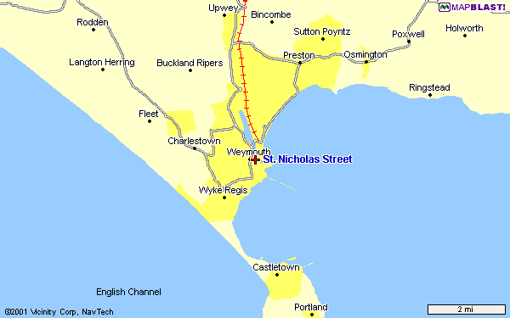
To the A35

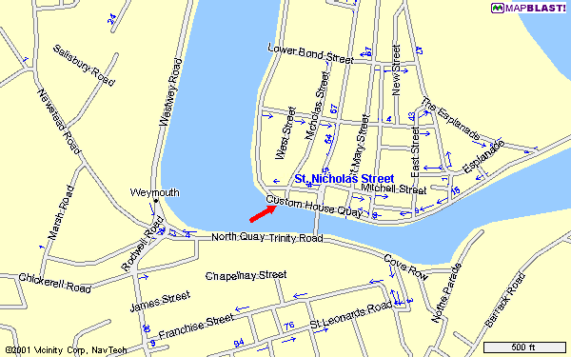
The Sailor’s Return is roughly where the big arrow is pointing

