By Andy Selby (heavily sub-edited by someone for whom English is not a third language)

Due to some very good, and some very, very dubious excuses, only four members actually turned up this year; with Charlie flying over on the rock hopper to avoid her appointment with Whisky Bravo (the coastguard rescue helicopter).
The Sunday night started well with Clive and Kim arriving in good time and tucking in to the Sailors Return Guinness. While waiting for Steve to arrive, talk was of good weather and tackle. The fishing reports were good and Vera was going to be our cabin boy for the week what more could we ask for!
Just before last orders there was a screech of brakes outside the pub and Clive peering through the haze of two or seven pints stated that it was Steve. There then followed a large crash causing people from up and down the street to peer out of their windows. Steve had lifted his tackle box (the size of my shop) from his car and, as with most of his tackle, all the metal fittings had rusted away, causing the box to fall from under the so-called hinged lid. All you could see from the pub was spools of line, tackle, weights and pork pies rolling down the road with Steve on all fours crawling after it, a sight that had to be seen to be believed.

Monday
After a good night’s sleep and Steve replenishing his tackle box, Richard’s plan was to trawl for sandeel on the shambles and feather for fresh mackerel as they had been scarce in the islands.
While Richard was waiting for the tide to slow before the trawl, we tried sandeel fishing and three new records were set. Steve had a 4oz Lesser Sandeel, while I had a 1oz Corbins sandeel and a 1oz Small Sandeel – fishing at its best!
[EDITOR’S NOTE: as neither the small sandeel nor the lesser sandeel is currently listed in the British record fish lists, both of these would have been British records, had our heroes thought to retain them for identification. Then again, since they were relying on Richard for identification, they would probably have turned out to be small garfish, or conger]
We then headed off to the islands, and were making good progress when 30 miles out we passed a small 20ft fishing boat which looked liked someone was waving to us. We went over and sure enough, they were in distress with a rope wrapped around the prop. The boat was brand new and fitted with every electrical device possible. Richard asked them if they had a radio and the crewman said “No but we have a great CD player”. They had come that far no radio or communications equipment, flares or anything. We had to wait with them until the coastguard arrived by helicopter to drop them off a radio and then the helicopter waited for the lifeboat to arrive to tow them back.

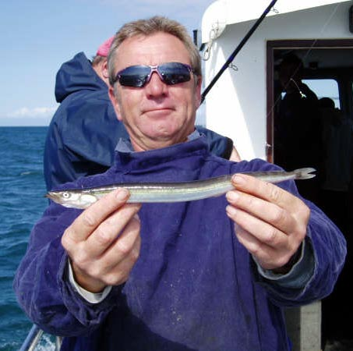
Stevie’s record lesser sandeel. One of his finest achievements in life.

When we arrived in the islands we went straight to the tope grounds where many good fish had been caught the previous week. Sadly it was a case of “You should have been here last week,” as the tope had gone. We had just one small tope, several bull huss and some dogfish.
To finish the day off we went to an area of rocks about 2 miles west of the harbour called Burhou. There we were light tackle fishing, catching pollack to 10lb in 30ft of water. It was some of the best sport any of us have had with pollack. I was trying to catch a big wrasse on crab and caught fish up to 3lb, many of them spectacular red in colour. Then Kim caught a 5lb 6oz ballan on sandeel – a superb new record.
That night we ate in the Indian and consumed plenty of ice-cold lager to help cool the sunburn.

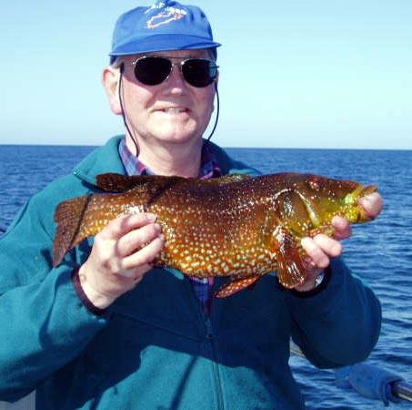
Kim briefly held the record with this lovely ballan.

Tuesday
We decided to go bass and turbot fishing and caught about 20 bass to 5lb and 3 turbot. Steve lost, so he says, a monster turbot and did we hear about it for the rest of the week! We also had our fill of hard fighting pollack as well.
We were all extremely hungry, especially Steve after his tussle with the huge turbot, so we ate in Maris Hall and all ended up having their legendary steaks.

Wednesday
Charlie joined us today, as the sea was like a mirror and sun was shining. To celebrate her presence, Richard took us to an area he had never fished, called “The Washing Machine”. This was an amazing place – the only time I have ever seen water create a waterfall effect 8 miles out. A strong tide runs through and drops over a ledge from 60ft to 100ft causing huge whirlpools and the waterfall effect, and it really was just like being spun round in a washing machine .
However, it was useless for fishing, so after catching nothing there we went to another bass and flatfish area where we caught 25 bass, 6 turbot and a brill. We ended up in Burhou again catching the big pollack. I was still trying to get a big wrasse, when Charlie shouted she had a good fish. It ran like a pollack but ended up being a 6lb 2 oz Ballan. The record had gone again!
That night we ate in the new Thai Restaurant, and what great food it was. Steve kept it down for at least an hour.

Thursday
Again we did much the same sort of fishing and Steve did catch his first ever turbot – a massive 3lb specimen. We also had our first boat Barbie with Vera looking very pretty in his apron [EDITOR’S NOTE: Was this a barbeque, or was Vera being dressed up as a Barbie doll for the perverted pleasure of the crew, or both?].
We had about 25 bass, 7 turbot and 1 brill and again went to Burhou for our fun hour.
We were all again hungry and the popular vote was to eat in the Maris Hall again.

Friday
We stopped on the deep water wrecks on the way back to Weymouth were we caught plenty of cod, ling and pollack
All in all a good time was had by all. It was disappointing the tope had disappeared, but the light line fishing made up for any disappointment. Next year’s trip has already been planned for the 29th of May through to the 2nd of June. We have 4 names already (Jari x 3, myself), so please let Ben or Adam know if you would like to join the trip.

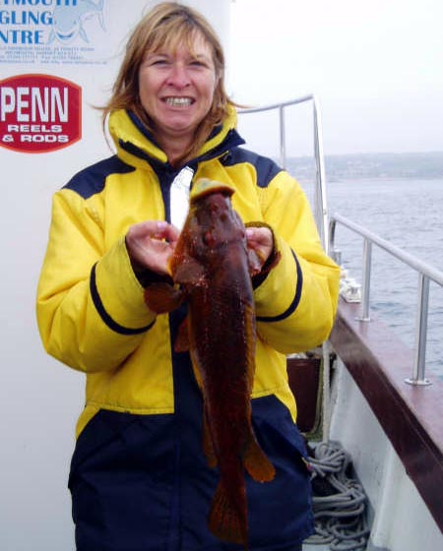
Then Charlie snatched the record away with this six pound beauty. Turn it sideways, Charlie!

