J ust when you thought it was safe to go back on the water – Newsletter 29 – and this time it’s personal. Having left you alone for such a long time, I have the finest collection of marine stupidity ever to appear in print. If that seems to be overselling the contents of this cheaply produced… er, now what’s the correct phrase here? Collection of random words? It’ll do for now. So, if that seems to be overselling this cheaply produced piece of shit, then you’d be right, but I’ve got to ensure you keep reading through to the advertising at the end of the document, otherwise we’ll lose our lucrative sponsorship deal with the best tackle shop in Weymouth – Reels and Deals.
In this edition’s fun-packed fishing jamboree, there’s news from five (count them, FIVE) actual fishing trips that have take place on the sea (yes, that’s SEA, as in Really Wrecked Sea Angling Club, in case the relentless cancellations had caused you to forget), the report of the annual dinner, the low-down on the Channel Islands trip, a look ahead at the trips we have lined up, and a very interesting club notices sections at the end (just before the advert for our Sponsor – Reels and Deals “The freshest ragworm on the South Coast”).
If that summary of the goodies contained in this newsletter hasn’t caused you to turn the light out, roll over and go to sleep, then you’ve probably been at your little one’s Ritalin. In that case, read on, there’s stuff in here even the most powerful drugs are powerless to overcome.

Annual dinner 2004
I’ve never really known whether to call the dinner which takes place in, say January 2005, but which dishes out awards for fish caught in 2004, the 2004 annual dinner or the 2005 annual dinner. I don’t expect this to engage your interest particularly, but if anyone knows of a convention I might employ here to solve this mighty conundrum, I’d be glad to hear it.
That dull preamble does not in any way represent the quality of entertainment on offer at the annual dinner, which was, as usual, out of the top drawer. The cabaret act in which a troupe of thirty Russian Cossacks juggled the flaming parts from a selection of Abu multipliers from the 1960s was particularly enjoyed by all, especially by Clive, who, despite being absent due to illness was nonetheless still able to name all the parts in midair, while stripping a Penn Senator and giving it a quick service blindfold. This was, all present agreed, a most impressive performance from a man lying at home on his sickbed recuperating from an acute case of pneumonia. Adam tells me I hallucinated the whole thing, due to my having challenged Jari to a game of “Finish up the leftover absinthe”, but to be perfectly honest, I can’t remember any such game taking place, and I rather doubt it did as towards the end of the dinner, I was too preoccupied in hiding from the hideous screaming bats that were dive-bombing the table, to take part in any silly drinking games.
Apart from Clive, other notable absentees did not include Stevie, who insisted on turning up, despite repeated and urgent appeals from all fellow club members. New member Nick Coster also put in a first appearance and showed himself to be particularly unable to hold his absinthe, as you’ll see from the accompanying picture.

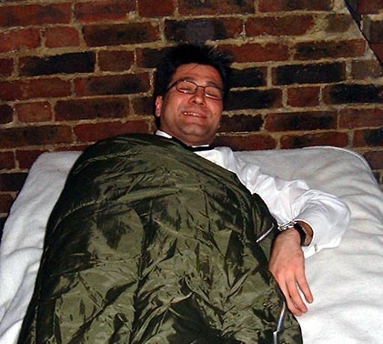
Nick headed to bed (fully dressed) well before the party even got going...

The club awards went to the usual array of undeserving causes, as once again, Adam and I refrained from awarding all the worthwhile cups and medals to ourselves, on the grounds that you lot might mutter ungratefully about a fix or some such nonsense. A full list of the recipients of the awards is included in a separate document for those of you who give a stuff.
There was a splendid array of NEW AWARDS on offer this year. These included the Grim Reaper Trophy, given to the angler with the closest encounter with death in the year, the Cunty Hat Award, given to the angler who brings the cuntiest hat on board during a club trip, and the Pathetic Excuse Trophy, which ought to be obvious, even to the likes of Neil Cook and Tom Fowler. This last magnificent trophy was donated by Mr. Andy Selby of the Weymouth Angling Centre, and consisted of some dead hermit crabs, delightfully embalmed in a clear resin, resting on a wooden plinth. I can see this becoming a real favourite in years to come.

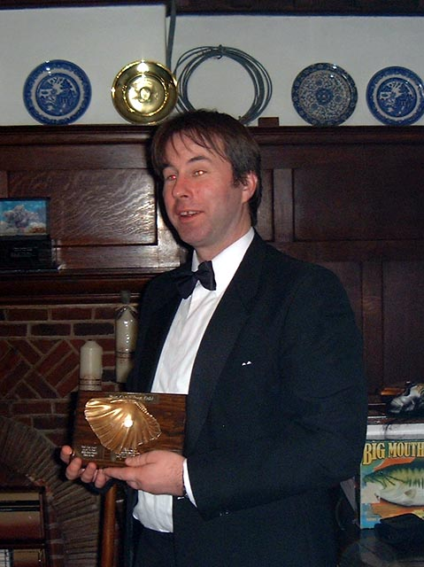
One of the club’s shambling idiots picks up a well deserved lifetime achievement award in the field of gross stupidity.

The biggest shock of the night came when the winner of the Steve Newham Cup for Optimism and Cheer was announced, and despite being nominated a record three times, Steve Newham failed, for the first time, to win the Cup that bears his name. Who could possibly be dour, miserable and unpleasant enough to wrest the award from Stevie? Look in the awards listing document to find out (Hint: he is a really miserable fucker).
The speeches were of their usual low standard, improved markedly this year by the complete absence of any speeches from the floor. This nonsense must stop at once. We don’t pay nigh on £2.50 a head to sit in our seats and not be forced to listen to drunken idiots rant on interminably about this or that miniscule fish they may have caught. Next year, the committee expects everyone to have prepared a short 30 minute address on the topic “Why Adam and Ben are the greatest anglers ever”.
The post dinner entertainment was this year housed by Mr. Steve Newham, as Mr Adam Frost not unreasonably refused on the grounds that “I don’t want to be getting up at the crack of dawn at 2pm and find Two Dogs in my living room, still going on about the virtues of circle hooks for bass fishing.” I have vague and incoherent memories of being chased from the premises by men brandishing pitchforks and flaming torches at about 3am, but that may be due to the absinthe.

Outings so far
Some of you may feel that we never get out and that the weather gods are always against us. In fact, although we have had both spring Weymouth trips blown off this year (which has never happened before), we have also managed to get afloat five times from Sussex ports, which is three more than we managed all last year and more than we’ve managed in the first half of any year since 1999. So gird up your butt pads, read about the non-stop action and then call Adam to book up a trip.

Friday February 4th
After several cancellations, we finally managed to get out after the fat early season pollack. The weather was lovely and flat and it wasn’t particularly cold for the time of year. Dave headed for a wreck about 20 miles South East of Newhaven, in the region of the sub, which we have fished several times in the past.
On the first drop, Nick Coster landed a lovely pollack of 16¹/₂lb, which got everybody going. Then, on the third drop down, Adam hooked into a positive monster of a fish, which bent his 20lb class rod further than it had ever bent before. This fish was so massive it might even have beaten Adam’s magnificent 33lb tope for the accolade of the best fish ever taken on a club trip, or indeed by any angler ever.
Unfortunately, we shall never know, as Nick Coster and every other angler aboard skilfully threw a loop of line around Adam’s gear, resulting in the biggest tangle in the history of angling. Adam’s fish, being extremely wily as well as enormous, realised something was amiss and used the opportunity afforded him to make good his escape. Bad luck Adam!
Dave then decided to move to other wrecks, pausing only to advise that cod were likely to be very thin on the ground, and that everyone should concentrate on the pollack. This proved to be entirely true with a final tally of six pollack in the 8-10lb range and 21 cod up to 17lb, the largest falling to one of Two Dog’s eleven rods.
Chrissie chose this trip to become our third woman member, and opened her account with a very fine 14lb cod, which pulled almost as hard as the rudd in Farmer Giles’ lake, apparently. The Smurfs were on very good form all day, providing endless cups of tea and even a little sympathy when Adam’s Abu 7000 Lever Drag went sproing and blew up for about the fourth time. Colin reverted to type for this trip and changed rigs every drop down, adding more and more outlandish accoutrements to his line each time. Less usually, Jonathan fished very well and caught several fish! Whatever next?

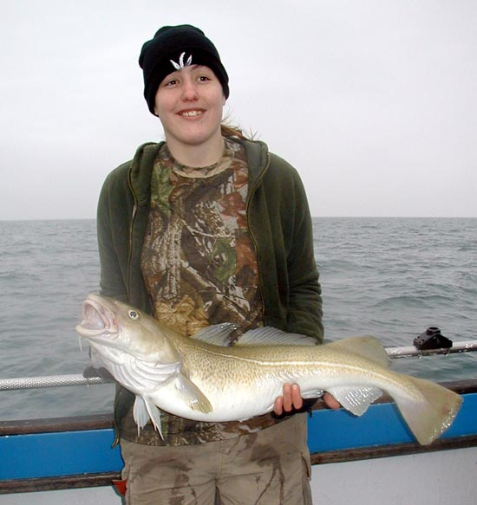
Chrissie shows off a lovely double-figure cod and wonders why Adam hasn’t let her come out on a boat before now.

Thursday March 31st
This was another attempt to get stuck into some fat spring pollack. The tide was flooding for most of the day, so Dave headed for a small wreck about 26 miles to the South West. The wreck lay in 200’ of water and with a fairly large tide, fishing time over the wreck was quite short.
Despite the depth and tide, Two Dogs decided to use a 12’ spinning rod and an Abu 5000 reel, while Clive opted for a 7’ spinning rod. These outfits had the major advantage of folding completely in half under the strain of the lead weight. Thus, when a fish took, Clive and Mick were able to play the fish directly from the reel, rather than allowing any inconvenient shock absorption from the rod to come into play. “Always pick the right gear for the job in hand” – a sensible motto and one which members of the Really Wrecked SAC can never be accused of adhering to.
It was hard work all day, but perseverenace did pay off, with a fish or two coming every couple of drifts, and everyone catching. The final tally stood at 15 pollack to about 12lb, one cod of 16¹/₂lb and four cups of tea – making it another bumper day of cushy treatment from the Smurfs, who are beginning to spoil us.

Tuesday May 31st
It’s at about this time of year that proper fishing starts, when real men stop messing about with girlie species like pollack and start congering. The Really Wrecked SAC is lucky to be blessed with an abundance of real men, angling giants such as Chris Grant, Phil Pepper and Neil “Rab” Cook. Those of us fortunate to have fished with the likes of these owe them a debt of gratitude for their strength of character and skill in dealing with that most fierce of predators, the conger eel. For those of you who don’t like fishing tales that involve huge eels, strong men and mighty battles, look away now (Les, Colin, Clive, Adam etc. this means you).

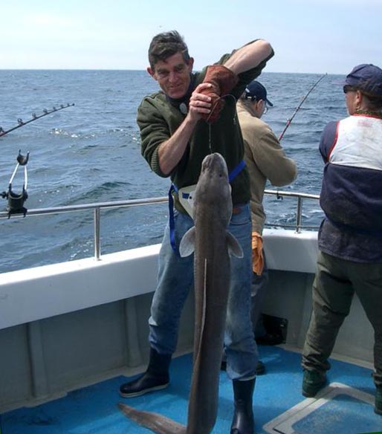
A mighty fifty pounder for man-of-steel, Colin.

The day started on the drift, with our heroes warming up on mid-sized cod and pollack. But the real action did not start until the hook went down and the big baits went into the water. Within minutes congers were sniffing around and moments after the first indication, three rods were bent double as man and beast commenced battle.
Luckily for the beasts, the men in our club in most cases lack any skill or common sense, so many of the eels were lost, but a significant number were not, giving a final tally of 21 eels. Of these, three were over 50lb, with Rab taking a fine fifty pounder, Phil Pepper overpowering a fish of 56lb, and Chris Grant landing the pick of the bunch with a fine 59lb fish.

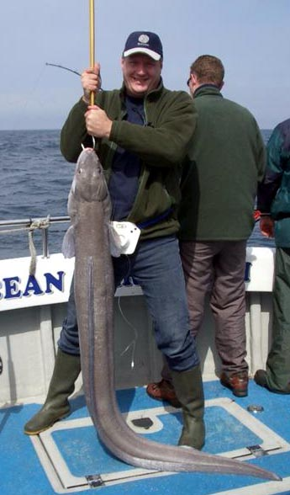
This brute was massive, and the eel was pretty big too, at 59lb (the old ones are the best).

The other girlie lightweights soon tired of this man’s sport and fell to fishing for smaller fish. Among these were three gurnards, including a splendid new club record to Colin for a 1lb 9oz 8dm red specimen.
Alderney trip: May 30th – June 3rd
The report for this extravaganza has been produced by our mole on the trip, and therefore appears as a separate document included with this one under the byline “Andy Selby” (not his real name).

Monday, June 27th
We all know Les Whiteman. This lovable rogue from Newick joined the Really Wrecked SAC a good six years ago as a Country Member, and yes, Les, we do remember.
But he has a dark side. Some years ago he took a wrong turn in life, forming the breakaway wing of the Provisional RWSAC, a shadowy organisation calling themselves the Drippy Hookers, or something similar. As President/Secretary of our Newick-based arch-rivals, Les organises the trips and had organised a trip out of Brighton aboard the Aquamandar, a 32’ Aquastar. Unfortunately, the Weepy Shandy Drinkers could only find four members man enough to take to the sea, so four of our sterling members offered to help fill the boat.
As this was a Les Whiteman organised affair, when the crew arrived at the boat, was well as the four Really Wrecked members, there were also SIX Fluffy Lesbians, making a total of ten in total. This made things rather cosy on the smallish 32’ boat, particularly as the Frilly Tutus felt it necessary to make up for their insecurities regarding their sexuality by bringing on board the biggest and most manly B&Q brand tool boxes on wheels that they could possibly buy. The pitiful wailing they made trying to lift these items over the gunwhales was as loud as it was embarrassing, but eventually they were all settled in, leaving approximately six square centimetres to fish from.
The boat headed off towards Newhaven, ending up over a wreck in the vicinity of the East-West Buoy. A force 3-4 North Easterly blew all day, which, combined with the tide, meant fishing on the drift all day, although the prospect of anchoring for conger had the six Newick weaklings mewling and fainting like newborn babies in any case.
From the wrecks they drifted, our mixed crew managed to take 20 cod and 20 pollack to about 10lb with most in the 3-6lb range. The fish generally fell to 6” red shads fished on standard gilling gear. Of the decent fish, Adam managed five cod and three pollack, making him top rod for the day. Normally I would pour scorn over his insistence that I relate this to you, but as it showed the strength and skill of the RWSAC compared to the Fairy Princess SAC, I am pleased and proud to be able to bring this news to you. Les, on the other hand, ponced around all morning, trying to sort out his club-mates’ unpredictable fits of weeping. In the afternoon, he reverted to type, putting on a display of unrivalled misery and bad temper.

Friday July 8th
Despite this being Dave’s birthday, he kindly agreed to take us out fishing. Mind you, what better way of celebrating your birthday could there be than spending all day with the fine anglers of our club? Answers on a postcard…
The day started fantastically well with Frank of the Cresta Café telling us at great length about his latest fishing exploits, including 60 cod to 90lb at the weekend, and 500 bass to 60lb in a short evening session using only a 2” length of bacon rind as bait. He then held forth about his latest series of 200lb tarpon catches from the beach at Shoreham, his 600lb bag of bronze bream on the waggler in the Sea of Tranquility and what it was like to be awarded the Nobel Prizes for Literature, Peace and Physics in the same year as winning Winbledon, the US Masters, scoring the winning goal in the Champions League final, becoming the first man on Mars and preventing global warming with a unique use for endless quantities of hot air.
This was the baptism for a lucky new member, Smiley Adam Sobot, who had come along to see what he could catch on his 13’ coarse match rod.
The sea was much flatter than expected so Dave set off for a wreck about 20 miles from Newhaven. On the first drift, five rods bent into fish straight away and four nice pollack came to the boat. The reason that only four fish came from five hook-ups was that on the way up, Rick’s fish had greedily swallowed Adam’s lure, or possibly, Adam’s fish had swallowed Rick’s lure on the way up, so the fish was shared. Smiley Adam Sobot broke his duck with a lovely 13lb pollack and for a while things looked pretty good.
This seemed to be confirmed when Rick hooked into a very large fish indeed. He was using Adam’s old 20lb class rod which, forensic tests have confirmed, is in fact an 80lb class rod, which Adam had crudely disguised as a 20 with Tippex in an attempt to scotch rumours of his crude and unsporting approach to fishing. This broom pole was hooped over as something enormous battled over every inch of line all the way to the surface. The tide took the fish under the boat, so no-one could quite make out what it was, but the consensus was that, given the way it had fought, it was probably a VERY large bass. Very large indeed.
Unfortunately, the leader knot became jammed in the tip ring and, ignoring the advice of his fellow club member to jiggle the tip until the knot slipped through, Rick simply slackened off and then wound in again. Alas and alack, the fish used the slack line to throw the hook and disappear into the depths, leaving a very distraught Rick to bewail his bad luck. The entire crew joined in commiserating with the poor fellow with loud guffaws and other supportive noises.
As the tide slackened, so the fish became harder to catch, and for the rest of the day, it was a case of moving from wreck to wreck picking up the odd pollack or cod here and there. When the hook went down, there was a brief flurry of eel-related activity, during which Smiley Adam hooked another first, with a nice conger of 35lb on 30lb class gear.
The only other conger taken was another good eel for Chris Grant, who landed a very short and fat 57lb fish. Adam has asked me to stress just how short the eel was. Basically, when Pete and Dave, who are neither of them giants, lifted the eel’s head to shoulder height to weigh it, its tail did not reach the ground. It was shaped like a barrel. But funny shape or no, it was the second largest eel taken this year, putting Chris in first and second place for the Really Eely Tankard. Adam, tragically, missed out on the eel action, as first drop down he hooked the wreck and by the time the three hours had elapsed that it takes him to retackle, the all-too-brief window of opportunity had slammed shut in his face.

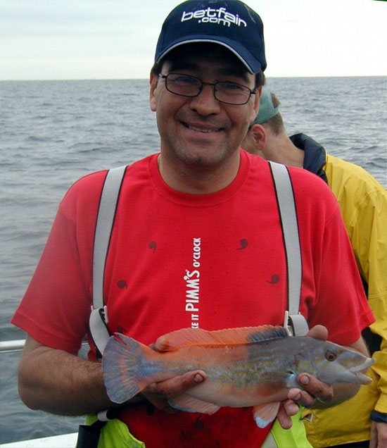
Nick’s superb cuckoo wrasse – the closest to a British record by any club member.

On top of the 12 pollack, three cod and two eels, Chris also had the outrageous luck to foul hook a 5lb 1oz bass on killer gear (i.e. ripping with a pirk), putting him in prime position in the race for the Bass Cup. But the best fish of the day was undoubtedly Nick Coster’s superb 2lb 2oz cuckoo wrasse, taken on baited feathers. This fish is a massive 86% of the national record, making it the best fish ever taken by a club member. Well done Nick!

Club News and notices
Read on for the usual assortment of lies, half-truths and nonsense, with a slight sprinkling of useful information thrown in.

Floating gin palace
For those of you, like me, who are too damn lazy to go on any fishing trips, you might like to know that the Smurfs have splashed out on a shiny new boat. The new one is bigger and faster than the old one, being a 38’ Aquastar boasting a top speed of over 22 knots. Unlike Richard English, whose jet-powered floating greenhouse was reputedly able to reach 38 knots but which never went over 6 knots due to his insane insistence on using less fuel per trip than Ken, Dave Smurf promises that on flat days, he will actually open up the throttle.
Ocean Warrior III is very large, with enough space for six to fish down one side on the drift in comfort. It sports a built-in livebait tank, a single engine box in the cockpit area, and is very quiet and very comfortable to fish from. She’s as nice as any other boat we’ve fished in.

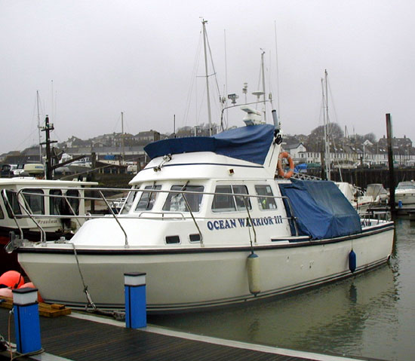
The magnificent new Ocean Warrior III at berth.

Home security
Tragic news from Weymouth. Tackle shop owner and bon viveur, Andy Selby, suffered a major setback in his quest to become the English angler (by which I mean an angler who fishes for the English National Team and not an angler who tries to catch Richard English) with the most tackle. In the dead of night (i.e. around noon on a bright sunlit day), a master criminal and catburglar (i.e. a lurching and semi-conscious drug addict) breached the watertight security surrounding Selby Towers (i.e. walked into the open shed) and made off with dozens of reels, some of which are reputed to be worth literally pounds.
As we all know, Andy is a man noted for his alertness and quick thinking so when the criminal mastermind staggered into the Weymouth Angling Centre (which is Andy’s “tackle” and “bait” emporium for those who never read these newsletters) muttering darkly about having a load of crappy reels to sell cheap, he was told by the proprietor of the shop (one A. Selby) to pick his cheap and nasty collection of tat off the counter and take them elsewhere. This is all, by the way, more or less true, you really couldn’t make it up.

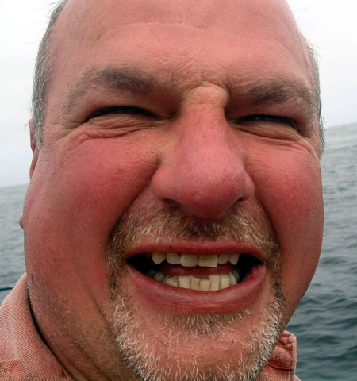
Would you steal reels from this man?

Luckily Andy’s boat owning chums did not share his distaste at the low quality kit the light-fingered genius was flogging, and bought loads of the gear. This meant that, when the penny finally dropped some hours later, Andy had the enormous pleasure of paying Richard and co. vastly inflated prices (still lower than those at the Weymouth Angling Centre) to buy his own equipment back again. So now Andy’s large collection of Shakespeare and Okuma reels is safely back under lock and key. If anyone else should suffer a similar fate, make sure you call Andy “Clouseau” Selby to investigate.

Outings, including all-new bookings
Below you’ll find a complete listing of all the trips we have planned for later this year. I’d just like to pick out a few highlights for you, so you’ll have a rough idea of which to avoid going on if you’re desperate to miss being confined on a boat with the two finest anglers of their generation (that’s me and Adam, if you’re just nodding off).
The two autumn Weymouth trips promise to be real humdingers. The first will allow us to take advantage of the superb ray, tope, bream, bass and turbot fishing available on inshore marks at that time of year, while the second is a new and spectacular departure. As you may know, Weymouth is home to some huge ballan wrasse (larger than the British record if the local divers are to be believed) and November is the time to fish for them, as the smaller fish have buggered off, the kelp has died back, but water temperatures are still fairly high. A kind wind is pretty essential for this, and given the time of year, the trip is quite likely to be blown off, but if it isn’t it should be fantastic.
We still haven’t managed to get out with the Smurfs to fish the famous tope hole off Beachy Head, so we’re looking at the August trip to try and make this happen. It should be great, as tope pull back a bit and if there are a few about, the action can be amazing.

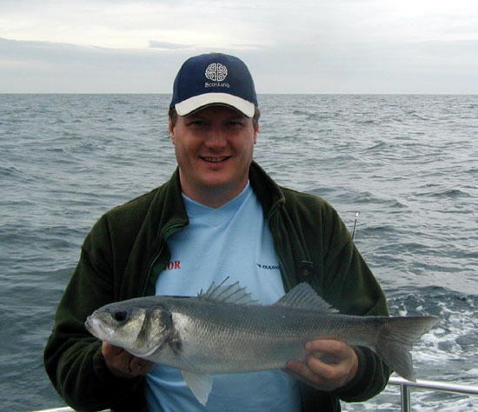
Fishing can be easy – just ask Chris about this foul hooked five pound bass.

Newhaven trips have an “N” and Weymouth trips have a “W” and are in a kind of maroon colour.
W Fri/Sat 29th/30th July Summer trip
N Tuesday 30th August Tope/bass/conger
N Tuesday 13th September Conger/bream/bass
N Friday 30th September Conger/bream/bass
W Friday 21st October Rays/turbot/bass/tope
N Monday 31st October Conger/bream/bass
W Friday 11th November Ballan wrasse
N Monday 14th November Offshore conger/inshore cod
N Monday 5th December Inshore cod/whiting

There is also the possibility of a bass/pollack trip on the Saturday the 20th of August. The tides are very big, so it depends very much on whether there are any fish about. I’ll keep you informed. Please also note that the trip on the 13th of September with the Smurfs is a new booking, so check your diaries and let Adam know if you are interested in any of the new trips.

Lead Making Extravaganza!
This Saturday the 23rd of July sees the return of the most exciting event in any angler’s calendar – the chance to join Adam in a feast of lead making. It’s vital that some of you help him in this endeavour, as we all use and lose the leads, and it isn’t fair if Adam has to replace them all. And in fact, it’s pretty good fun melting all that lead and splashing it around like warm water. So please give Adam a call and he’ll tell you when in the afternoon to turn up.

For sale
One Abu 7000 Lever Drag reel In excellent condition, hardly used due to tendency to fall to bits whenever it is required to retrieve line. Ultra modern design, featuring chocolate gearing and ferric oxide (aka rust) level wind. “An excellent reel – on a par with the Charter Special and Shakespeare Fulmar” – Sea Angler review that was spiked. Contact Adam Frost for more details.

That’s it from me. Remember to book up those new trips cos there are still loads of fish to be caught. See you all soon.
Cheers,
Ben

