F orget all the usual stuff about bad weather and cancellations, about whether Adam or Chris Grant is the bigger tosser. Just sit back and read about some fantastic fishing and then either pat yourself on the back for being clever enough to book up or sulk because you missed it.

Weymouth Summer trip 2005
This trip never ceases to amaze and entertain me. Every year there’s something new and amazing, or amazingly stupid to reflect on. As has become the norm, we went to bed fairly early on the first night, the better to be prepared for the day ahead. The A Team dreaming of a day’s wrecking with Richard full of huge eels and monstrous cod, while the B Team prayed for slightly less than 12 foot of swell this year inshore and a better stamp of wrasse and dogfish with Ken.
Day One dawned breezy, as it always does, the rule being that it is always too rough for the B team to go and fish the Kidney Bank for blonde rays on their inshore day. Day Two is then always flat calm so that the A team can fill their boots with blondes before sampling various other inshore delights that were inaccessible due to mountainous seas the day before. Not that I (as perennial B Team loser) am bitter.
As usual, the B Team had a choice of some magnificent wrasse fishing or some breaming. This year, we chose the breaming, hoping at least to have a lot of bites. Well, the bites were there all right, but what came up for the first hour and a half was 90% dogfish, 10% pouting. Another great start for us.
The A Team roared offshore in One for his Nob and no sooner had they started to drift the first wreck when the ling, cod and pollack began to hit their lures. The fish were a good size too, with several doubles.
Back on the B boat, Clive, Kim and Phil (of the Pepper variety) – three summer Weymouth initiates – were getting a taste of what they had been missing all these years. Phil’s blooding came with the capture of the smallest conger eel in the history of angling, which his ragworm bait had seized in its ferocious jaws and had refused to let go all the way to the surface. This was one of three eels taken in an action-packed morning session, the largest being a mighty 12lb.
Not to be outdone, Clive and Kim were also among the fish, with huss of almost seven pounds, and bream to well over a pound. Sadly, fish like these were the exception, and what we mainly caught were dogfish.
Back on the A boat, the crew had eventually tired of hauling in strings of cod on light gear, so down went the anchor and out came the big boys gear. A period of calm followed. Quite a short period if truth be told, as some three minutes later a couple of large cod smashed into their baits.
This was followed by an endless conveyor belt of conger up to around the 50lb mark. It was hard to pick out any particular heroes in the action, as everyone was catching fish, although plenty were dropped too (what do you expect, they are useless).
After several hours of this, 30 cod, 30 pollack, 30 eels and a few ling had been taken, and the A Team were happy to head inshore, exhausted by their trials.
The B Team were quite keen to try something different, so despite Tom’s insistent warnings, we decided to have a few drifts over the Shambles for turbot and brill. Andy (he of the stolen reels) being perverse in the extreme, decided that as we had no record lesser weever, he would set his stall out for them, and fish tiny hooks (so what else is new?). As you probably know, the lesser weever is the only fish in UK waters with potentially fatal venom, but with a prestigious Team England angler and tackle shop owner, there would be no chance of any mishaps, assuming that by some miracle, he actually caught one.
Several barren drifts followed, until Andy bent into a leviathan on his small hook paternoster. Bravely, he battled the monster to the side of the boat and the waiting gaff, where it was revealed as, blow me, a 2oz lesser weever. Carefully he brought the poisonous creature on board and, taking especial care of the three venomous spines in the first dorsal fin, and the further spines in each gill cover, he started to unhook the beast.
The keys to handling tricky customers like the weever are respect and common sense. It was therefore no surprise at all when Andy let out a loud yell and turned white as a cod’s belly, while sucking his index finger.
With such a potential disaster in the offing, the practical side of the B team rose to the surface in an instant, as helpful hints to alleviate the pain and reduce swelling of the already nasty-looking sting came flooding out. I have never heard such a ridiculous collection of old wives tales and plain lies in my life.
“Suck out the poison, Richard,” was among the less outlandish suggestions. Then there was “Rub it with a tench” and “Cod’s roe’ll fix it”. But my personal favourite was “Human urine will neutralize the poison.” Strangely, this last suggestion seemed to gain total acceptance among us, and we all offered to piss over Andy if it meant saving his life.
In the end, he plumped for the least ridiculous but probably most painful nonsensical suggestion as he plunged his hand into a beaker of boiling water in an attempt to destroy the proteins in the venom. Not only was he suffering from a potentially fatal sting, but he also now had third degree burns.
With Andy is some considerable discomfort and the fishing poor, we did the decent thing and stayed out fishing fruitlessly for turbot for another couple of hours. By this stage Andy’s swollen digits looked like bananas, which we all pretended to find hilarious to try and keep his mind off his impending demise.
Back in port, there was a little time for swapping of fishy stories before we were taken off to the Gurkha – a Thai / Indian / Chinese / Mongolian restaurant with an all-you-can-eat buffet for a tenner. As it was a Friday, the chefs had prepared a LOT of food, and consequently, the buffet did not run out until Andy and Chris went back for a seventh time.
Day two started according to the script, with the wind dying down just enough to allow the A Team access to the Kidney Banks and all the other fabulous inshore fishing that we in the B Team had been denied.
For the B team, the day started on a wreck situated on a large piece of rough ground. This meant that there were likely to be fish everywhere, so that Richard’s limited skill at anchoring a wreck would not be tested. Almost as soon as the baits hit the bottom, ling hit the baits – ling of a good size too. The biggest went almost 26lb and there were several 20s.
After half an hour or so of top ling bashing we decided to go to another wreck, the problem being that if we stayed where we were, while we’d undoubtedly catch ling, that was pretty much all we’d catch and there didn’t seem to be any point in killing every fish on the wreck. Besides, we had other fish to fry, or catch, if you see what I mean.
Meanwhile the A Team had settled over one of Ken’s hotspots on the Kidney Banks and were awaiting the first bite from a blonde ray. They didn’t have to wait long, as blondes and dogfish found their mackerel fillets irresistible. In all, four blondes were taken, with the largest a fairly pathetic 9lb. All the fish were returned, so maybe next year they’ll be bigger.

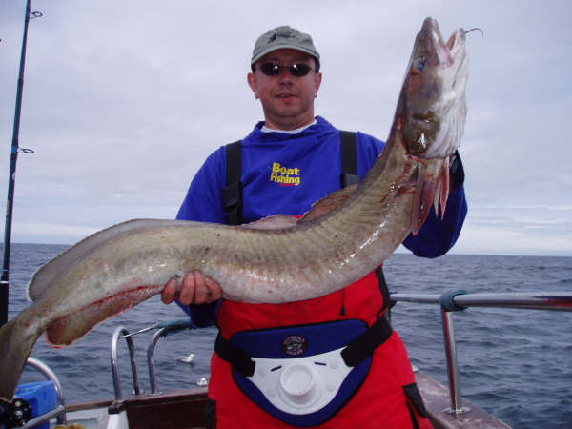
Smiley Clive holds up a nice 20lb plus ling

Having moved over slack water, the B Team were now in position over the new wreck. Down went the baits and within minutes someone was into a decent fish. After a few minues of suspense – cod? Eel? – it turned out to be ANOTHER ling. This was followed by a second and then a third.
Just as we were accusing Richard of steaming round the block and anchoring over the same ling-infested patch of ground, Neil somehow fluked an eel, and then Clive joined in the fun. The fish began to feed steadily, and we picked up a good number of eels, mixed in with a few more ling and codling.
I myself made an important contribution to eeling history with a 45lb fish on 12lb class gear. I am a modest man, so you’ll know I am probably underplaying it when I call this a fantastic achievement and one the committee will no doubt honour with one of our splendid trophies.
For the A team, a change in the tide meant that the Kidney Bank got just too darned lumpy for the big bunch of sissies and they decided to spend a couple of fruitless hours drifting for non-existent turbot. You may say that it’s a waiting game, and you have to put in the hours to reap the rewards. On the other hand, if you’re Tom Fowler, you say that it’s a complete waste of time. On the other, other hand, let no-one think I am endorsing the views of Tom Fowler, who, as we all know, is a miserable fucker.
Anyway, having put in the hours which means that one day someone else will catch a big turbot, the A Team anchored up on some rough ground at the East end of the Shambles. There the fishing improved out of all recognition, with six (count them) bream and two edible crabs for our keen crew. Both crabs beat the old record, with Scoop’s was the larger at a delicious 2lb 9oz.
But the story of the day belonged, yet again, to the B Team’s Andy Selby. Tiring of the weever jokes, he decided that it was about time the club had a red bream record, and so he set about targeting one of these, despite the fact that no-one has ever taken a red bream on a club trip.
God knows what a specialist red bream rig looks like. No doubt it involves tiny hooks and a five hook paternoster with attractor blades and rotating knives. But whatever it was, Andy stuck it on and announced to Richard that he was going to catch a red bream. Richard is used to Andy announcing he’s going to catch black bream when it’s too early in the year and no-one one else has taken any, and indeed, has stopped betting against Mr. Selby catching them.
But surely this time was different? Surely he couldn’t catch a red bream? But life is indeed strange, and no more than 30 minutes later, Andy was indeed pulling aboard a 4oz red bream. The man might not be able to handle weevers, and may be known for hundreds of miles around as an easy touch when it comes to protecting his reels, but he is also a genius. Let us not forget that.

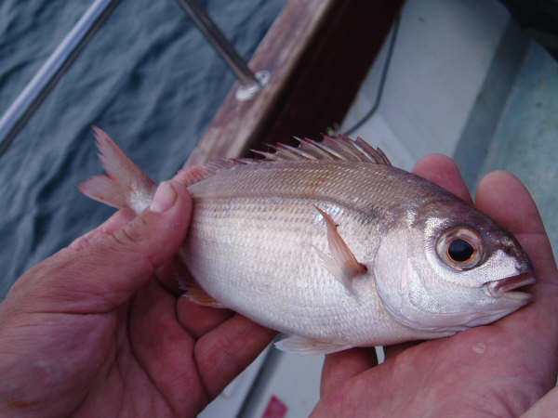
The miracle red bream, captured by Andy “Weevers ’n’ reels” Selby

Back on dry land there was the usual rubbish from the A team about catching more fish than us, which was patently untrue, and then it was off to the curry house for a lovely meal, spoiled only by me rabbiting on at the end of it to one and all about what a lovely time we’d had. This was followed by heavy drinking in the pub and the obligatory waking up of Sean at 1am to allow him to enjoy the drunken delights of conversation with Adam, Ben, Chris and Charlotte talking about, erm, I’ve no idea, actually, but I expect it was jolly interesting, especially by 4.30am when Chris and Charlotte were forcibly ejected from the room by a rapidly fading Ben. Still all good fun and I can’t wait for next year’s trip.

August the 30th
I never thought I’d see the day when I caught a 70lb eel and ended the day gutted (by which I mean disappointed, rather than done up like a cod once Clive’s done the business with his flashing blade. This is the story of an amazing day.
It started off pretty normally. We met up on the Coral Cabin, and endured the usual mixture of straight talking and common sense from Frank, who regaled us with tales of how crews on his boat caught, on average, more per day than the entire French fishing fleet in a year, set us straight on how to catch mahseeer and described in detail how he developed a cure for the common cold. With the weather set fair and the tide ebbing all day on a medium-sized tide, we boarded Ocean Warrior III and set off for a wreck about 24 miles offshore that was writhing with eels.
On the way out, we stopped off for mackerel and for a change found them to be fairly plentiful – certainly enough to supplement our cuttle. As we tackled up, Nick expressed surprise at some 12/0 Seamasters in my rig wallet, which was fair enough because they are HUGE hooks. I told him they were for that 1 in 1000 trip when a fish gets eaten half way up by a shark so I can have a go at the bastard.
When we arrived at the wreck, we caught a few more mackerel while Dave anchored up, and while we were doing this, Colin, naturally, had to do something a little different – he’s a bit of an Andy Selby wannabe in this regard – so he dropped his feathers down to the bottom and was rewarded with a decent tub gurnard and a new club record at 3lb 5oz.

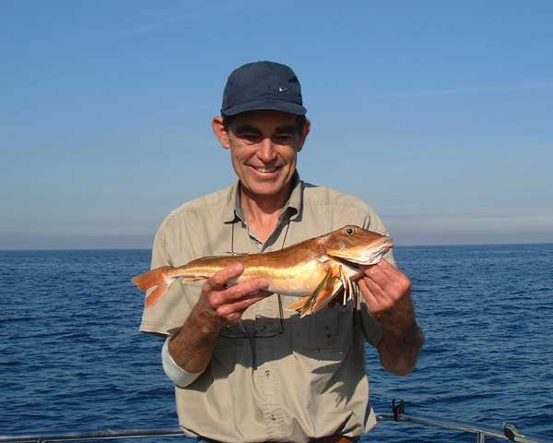
Colin’s splendid tub gurnard – yet another new record to the great white hunter

Then we were in position and ready to go. On went the usual 10/0 O’Shaugnesseys on 250lb mono, filled with tasty cuttle or flapper and down to the bottom. The usual suspects went down with bream gear but throughout the day only four small bream were taken. Anyway, back to the real men’s fishing, it wasn’t long before the eels (and cod) came out to play, with a good stamp of conger averaging about 35lb and the odd cod to double figures. I then hooked into a decent fish, which I played in my usual low key way, without the inevitable histrionics that accompany any fish Adam catches.
In short order it came to the boat, though I was quite puffed out, as it was quite a strong fish. Dave took one look at it and pronounced it at least 60lb, so out came the net and in went the eel with no fuss. In the net Dave decided it was more than 70lb so I was quite looking forward to the weighing, as the club record (taken by a superb angler, initials BE) is 72lb. Up went the eel onto the weighing broom pole and Dave and Pete strained to lift it off the deck.
Then came a sound that still haunts my sleepless nights. A hideous crack, and the supporting pole slipped, liberating the vast, angry eel onto the deck. Pete moved smartly off to get a gaff to restrain the beast, while we moved smartly out of the way of the leviathan as it thrashed and writhed around the cockpit area looking for wellies to munch, or so we thought.
Then, as it wriggled its way to the stern, its dastardly plan became clear – it was heading for the scupper and freedom! Now, I don’t wish to sound bitter, as I am by nature and happy and sweet-tempered soul, but as it began its journey across the deck, it looked to me as though, rather than trying to prevent my eel’s escape, the crew were playing eel footy, kicking it down the boat with the grace and elegance of Barcelona’s midfield until it lay, poised over the scupper. There Clive, rather than tackling the brute, and holding it safe until Pete could appear with the gaff, instead, like Ronaldinho, he applied the coup de gras and booted it out of the scupper.
I was not a happy camper. I became strangely silent for about 30 seconds – my potential new record eel had vanished without being weighed. But this is not the reason I was gutted. That came later.
After that excitement, we settled down to eeling again, with more decent eels coming up, until Nick hooked another superb fish – which he subdued without making a song and dance of it. At the side of the boat, it looked another worth weighing. This time the weighing proceeded smoothly, and the eel was pronounced a massive 85lb! What a fish. The only problem with it was that I had just lost my hold on the Really Eely Trophy and my favourite club record. I must confess to a slight twinge of envy at this stage, but this is not the reason why I was gutted.
Adam called me over. “That eel of Nick’s…”
“Yes, lovely fish,” I said, through gritted teeth.
“Yours was bigger.”

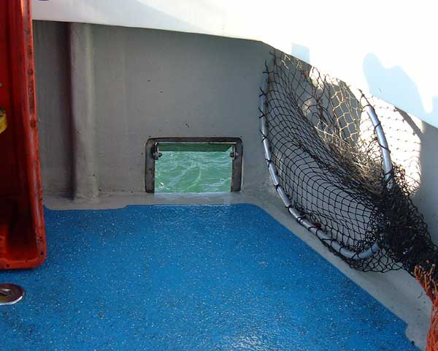
The Scupper of Doom

There is nothing crueller in this cruel world than Adam winding you up. He still maintains to this day that mine was bigger, but even THAT is a not the reason why I was gutted.
More eels followed, though none approaching the size of the two monsters. I decided to try something a little different. I took out a 12/0 Seamaster crimped to 400lb multistrand wire and looked at lovingly. Nick caught me at it. “What are you doing?”
“I was thinking of having a go for sharks.”
Instead of laughing at the idea, Nick replied. “You should do it. We talked about it – now just do it.”
So I did. Everyone else mocked as I strung two live mackerel on the hook and drifted them back from the boat and then set the ratchet. They openly scoffed as I cut up mackerel and threw the bloody chunks into the sea. They laughed when Tom pulled line off the reel while my back was turned, making the ratchet scream.
But they didn’t laugh nearly so much when the ratchet started making a very angry sound while Tom was nowhere near it. There was no scoffing as line melted from the spool while I blundered over to the rod, fumbled it out of the holder and tried to get my nervous fingers to work the clips on my harness.
This process had taken maybe 10 seconds, maybe more, and line is still peeling off the spool at a rate of knots. By now my heart is going like a scared rabbit on a pogo stick and everyone is staring in a “What the ****?” kind of way.
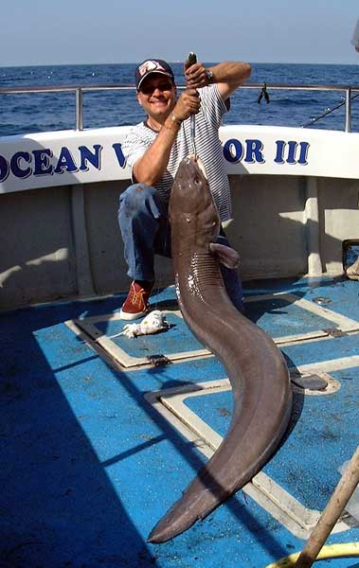
Nick’s splendid eighty – and unlike some eels in this newsletter, this one lived to fight another day.

“When do I strike?” It seemed an obvious question.
“Wait for the second run,” say the Smurfs, father and son in unison.
“Hit it now,” says someone else.
And still the ratchet is making that sweet, scary noise. There’s a burst of extra speed, like a wasp just stung the shark on the arse. Then it settles down again. Now the run has lasted at least 25 seconds, which is a long time when you’re pumped full of adrenalin. I really, really, really want to hit it, but I don’t. I wait. Another five seconds pass, then finally the run stops.
I wait for the fish to move off again, poised, ready to thump the hook home. And I wait. And I wait. And… nothing. Eventually I can no longer kid myself the shark has just fallen asleep, and I wind in to find a very empty 12/0. And that’s why I am gutted. So completely gutted.
I don’t really remember much else of the trip. I probably fished on, hoping it would come back, but it didn’t and I still have bruised shins from kicking myself. If truth be known, I probably hooked the mackerel wrongly – though the flimsy lower jaw instead of through the head, in an attempt to keep them alive longer – so maybe they ripped off the hook too easily. But I can’t help thinking… STRIKE ON THE FIRST RUN! STRIKE NOW YOU FOOL. HIT IT!!!
Ah well, you live and learn. Nice trip though, two big eels and lots of decent ones, plus some other fish and the ultimate one that got away.

September the 13th
Given the thrills and excitement of the last trip, it was hardly surprising that Adam and I should decide that, basically, eeling is a girl’s game, and real men go sharking. So we made up a couple more shark traces, got some balloons, and procured an onion sack, tub and mashing stick for making rubby dubby.
With this in mind, we piled into the mackerelling and caught loads of the little beauties to mash up, and spent the next hour or so battering the crap out of them before mixing in the bran and cod liver oil to make the perfect mix. Only then did we discover that the onion sack we had was more ‘hole’ than ‘sack’, so Adam discovered a hitherto unsuspected talent for darning and he patched up the sack with some 20lb line.
To be honest, he did a pretty poor job, and the rubby dubby looked destined to fall straight out of the bag as soon as we put it in. But then, looking to port I noticed an object floating towards us on the tide. As it approached, it became obvious that this was, in fact, an onion sack – in mint condition. We had been saved by a miracle courtesy of St Onion of Sacke. Now if that wasn’t a sign from above that we should be sharking, I don’t know what is.
So, while the others all fell to eeling and breaming, Adam and I drifted bunches of mackerel back on huge hooks hung underneath balloons, while the rubby sack hang at the waterline, slapping up and down in the waves and releasing a steady stream of delicious fishy smells downtide. Our balloons bobbed merrily in the slight swell on this lovely calm and sunny day at sea. All we needed was a shark.
The others began to catch, with the odd eel, mainly small, coming to cuttlefish. Unfortunately, the fish never seemed to settle into a regular feeding pattern. This was probably due to the fact that we waited all day for the tide to start running. It was a very small tide (about 4.2m) and it never really got going.
There was a brief moment of excitement, when Stevie hooked what looked like a decent eel. Only for all the fight to go out of the fish about half way up. It was big, though clearly nowhere near the gargantuan stamp of eel that we’d had the previous trip, but even so, Stevie wanted it weighed. It was very placid, and came to the net as quietly as you like and was weighed at a creditable 55lb. Unfortunately, the shock of being removed from the water and confronted by Stevie’s smirking visage proved too much for the poor little thing and it suffered a massive coronary and died.
We knew it was dead because when we returned the eel, it made like a pouting and simply drifted away on the surface. Dave suggested we throw a weighted sharking balloon after it as a marker and we’d shoot after it when we upped anchor.
This cold-blooded murder of an innocent by the black-hearted Newham provoked a period of intense grief among the crew, who had only known the eel for a short time, but had come to love it very much. This manifested itself in the spontaneous appearance of black armbands on all crew members. They may have been crudely fashioned from insulating tape, but the sentiment was heartfelt. Strangely, Stevie didn’t see the funny side of this.
After this burst of murderous activity, we settled back down into a state of relative torpor, with only a couple of eels to interrupt the gentle slapping of the sea on the hull. Well, that and a few bream and gurnards to the likes of Colin, Tom and Jonathan.
The biggest bream was a decent fish of 3lb 2oz. I forget who caught it as my mind was on other, bigger fish – sharks to be precise. Once again came the sound of the ratchet, just like last time. Only this time it was down to a fulmar which had tangled my line. How we chuckled when I was forced to bring it aboard in order to untangle the hissing, spitting ball of spite. Well, the others seemed to find it amusing.

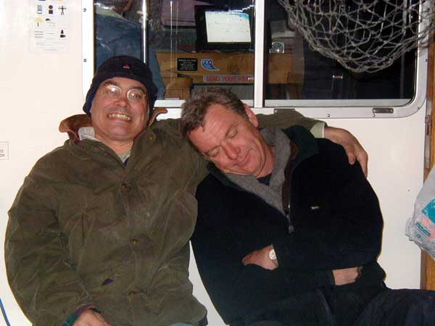
Contrary to news reports, the first gay marriage in the UK took place on Ocean Warrior III, presided over by skipper, Dave Elliot. Here, the happy couple relax after consummating their passion in the aft berth.

We finally lifted the hook and chased down the drifting murdered eel, evidence of Stevie’s crime. It had drifted about half a mile in three hours, which goes to show how little tide there was that day. As the eel was to be eaten, Nick “Quincy” Coster performed an autopsy, and demonstrated how, in the long hours between the eel finding the bait and Stevie noticing a bite, the eel had swallowed the hook, which had then pierced the gut lining and stabbed the defenceless conger through the heart, your honour. And that concludes the case for the prosecution.
We ended the day drifting another wreck at a very slow pace. I think someone had a cod, but I wasn’t really concentrating, being somewhat disappointed that the Channel hadn’t turned out to be seething with porbeagles. Ah well.

November the 14th
We had hoped that this might be a last go at congering for the year, but alas, it was too lumpy to get a long way off, so our lily-livered crew decided to fish inshore for cod.
It was a typical winters day, with plenty of swell to start with, though it did flatten off enough in the afternoon to make our decision to stay inshore look all the more cowardly. Obviously as we were cod fishing, everyone went down with a big bait to tempt the hungry cod. Showing enormous patience, our crew stuck with its avowed intention to catch cod for all of ten minutes before some Andy-Selby-like small-hook-fishing pouting basher, probably Colin, caught a dogfish or a whiting, at which point nearly everyone gaily abandoned big bait fishing to scratch around for whatever as there. All were tempted and all succumbed, except for the stout-hearted Mr. Frost, who stuck with his big bait all day.
It went well enough to start with, as Colin caught his first ever thornback – a fish of around 5lb. This, however, was something of false dawn, so perhaps if I just run through the catches, that’ll be enough of a flavour of the day. We had eight whiting, two small eels and ten dogs. A day when you count the dogfish is the definition of a crappy day.
But it needn’t have been so. Laying aside the sheer folly of remaining inshore, it is quite reasonable to fish with small(ish) hooks in such circumstances, as a big cod is quite likely to take a small bait. But to use a hooklength composed of 6lb mono or a strand of your wife’s hair is madness. If there’s a chance of a decent cod, you’ve got to use at least 40lb hooklengths – cod have sharp, pointy teeth. We dropped six or seven good fish through the day, nearly all of them bite-offs. A few cod and the day would have had an entirely different feel.
My personal highlight was Jonathan’s magnificent new record hermit crab, which was given an estimated weight (and a very generous one in my opinion) of half an ounce. Still, that’s half an ounce more living tissue than has been discovered on certain other hermits crabs we might mention.
The low point of the day came right at the end – a real kick in the teeth for anglers who had worked hard all day to catch. Somehow a brain-damaged cod managed to mistake Adam’s hacked and washed-out cuttlefish for a bait – I suppose in the low light levels it just blundered into the hook with its mouth open. So after all that we had to watch while Adam huffed and puffed his way to a 18lb 2oz cod – a lovely fish from rough ground. It just goes to show that sitting it out with a big bait and a heavy hooklength does sometimes pay off.
The sunset was lovely though, and that almost made it bearable. My apologies to Stevie and particularly to Les, who had to put up with my inane chatter all day. Even a pair of miserable sods like them don’t deserve that.

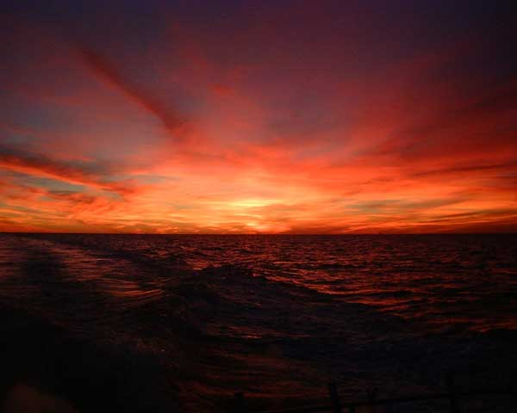
Mandrax Sunset Variations IV – more acid vicar?

Club News and notices
The Newhaven dates for next year are below, and some very important news about the dinner.

Fishin ‘n’ chips 2006
The annual dinner is to take place on the Saturday the 28th of January at the Crown Inn in Lewes. Book now to avoid disappointment. The menu will be published soon but make sure you reserve your place now at the most prestigious event in the pop calendar, or is that the Brits?
You will note from the dates below that the Friday the 27th (the day before, for those club members less intelligent than a ragworm (Neil Cook, this means YOU)) is a fishing day, so if anyone who has to travel a long way is wondering how to justify the journey, why not book up both the fishing and the dinner?
Most importantly – anyone who has a trophy from last year must return it to Adam as soon as possible, or sooner. We have to organise all that engraving so please get the stuff back. Thank you for your cooperation.

Outings on the deep blue sea
Take your pick from among the Newhaven and Weymouth delights below. Newhaven trips have an “N” and Weymouth trips have a “W” and are in a kind of maroon colour.
N Friday 27th January Inshore cod
N Monday 20th February Offshore pollack
N Monday 6th March Offshore pollack
W Monday 10th April Plaice
N Monday 24th April Offshore pollack or plaice
W Friday 12th May Turbot
N Monday 22nd May Eels and cod or plaice
N Monday 19th June Eels and cod or tope
W Fri/Sat 7th/8th July Summer trip
N Monday 10th July Eels and cod or tope or bass
N Monday 7th August Eels and bream or bass
N Monday 18th September Eels and bream or bass
W Friday 29th September Rays/turbot/bass/tope
N Monday 30th October Eels and bream
W Friday 10th November Ballan wrasse
N Monday 27th November Eels and bream or inshore cod
N Monday 4th December Inshore cod

BONUS TRIP!!!
Thursday December 29th : Newhaven : cod
This is obviously very soon, so book up now to have an early test of the all shiny new equipment you got for Christmas.
For this booking, call Adam at home, where he plans to become one with the sofa over the next ten days or so. If he doesn’t answer it’s only because he’s a deaf bastard and has to turn the telly up to maximum volume to be able to appreciate the subtlety of Mr. Clarkson’s hilarious wit in the Top Gear Snowplough and environmentalist-baiting Christmas Special, and won’t therefore be able to hear the phone. So please leave and message and he will call you back. His home number is 01273 478886. For all other bookings, call him at work on 01306743744.
That’s it from me for another six months (if you’re lucky). Remember to sharpen your hooks and strike all shark takes on the first run.
Merry Christmas one and all,
Ben

