S o here we are then. Stuck in front of another newsletter when we should be out fishing. At least I’ve got an excuse, Adam nags me on a daily basis for the six months it takes me to finally get down to writing it, but what’s yours?
Don’t give me that stuff and nonsense about wind and trips getting blown off, because despite a record number of cancellations in early spring, we have managed no less than eight trips this year. Knowing your mathematical abilities as I do, I will spell it out for you, that’s MORE THAN ONE A MONTH. So really there’s no reason at all why we haven’t seen more of you out this year. I’m sure by the time you’ve finished reading this finely-crafted piece of light fiction, you’ll be filled with fishy longing. Don’t waste that feeling. Phone Adam today and book a trip.
Some of you may feel a little aggrieved at being lumped in with the innumerate masses, but there is a good reason for this. I have noticed a strange and disturbing phenomenon on trips of late to do with the counting of fish. As you know, at the end of the trip, we like to jot down a score so we can work out how much damage we’ve done to the marine ecosystem, and when all fishing in the Northern Hemisphere ceases, we’ll be able to work out what percentage of the blame belongs to the Really Wrecked SAC.
So when the question is asked “How many cod did you catch, Adam/Nick/Chris/Tom/Dick/Harry?” the answer invariably comes back: “23 cod and 11 pollack, biggest about 28lb”. This gives a healthy total of about 400 cod and 200 pollack taken in an average day. Which makes it all the more puzzling when we come to gut/fillet the fish in question and the fish box contains three codling of around 4lb, a pollack that would have to spend most of its day hiding from blennies, three pout and a thawed out Ammo mackerel.
Clearly there is a thieving sprite living on the Smurfs’ boat who makes off with the best part of our catches. It’s either that or we’re developing a touch of Larryitis (also known as Frank’s syndrome). For those of you without a medical background, the symptoms are hallucinations of huge fish and a delusional belief that you catch hundreds of them every time you set out to sea.
There’s only one way to find out the truth. Every time you catch a proper fish (i.e. pout, poor cod, tiny wrasse, doggies etc. do NOT count, except for Andy S, Colin and myself), carve a large notch in the gunwhales of whatever boat we’re in, and at the end of the trip, we just count the notches. Some of the boats have got quite a hard gel coating, so please make sure your filleting knives are very sharp and you press VERY hard when making a notch. To prevent us getting confused over notches from previous trips, at the end of the day, Adam will go round the boat with his belt sander and smooth over the old marks.
I’m sure that if we all adopt this new system, we’ll soon get to the bottom of this mystery, and we’ll never again have to worry about how many fish we catch.

But before all that…
The annual dinner and awards ceremony was held in the now traditional venue of the Crown Inn in Lewes towards the end of January. As usual there was an excellent turn out of revellers, some of whom had actually been fishing in the previous year, but most of whom were merely looking for somewhere to shelter from the rain for a while. Strangely most of the awards went to people in the latter category.
There were a number of new awards. In particular there was the Grim Reaper Trophy, a magnificent gold skull-like concoction on a black plinth, awarded to the angler who communes most closely with the other side. It had, in fact, been awarded the year before to Clive for his plucky battle with pneumonia, but Adam and I didn’t get out of bed early enough in the afternoon of last year’s dinner to have time to make the trophy, so this year was the Cup’s first outing. The lucky winner was none other than Steve Newham, for his cold-blooded murder of an innocent conger eel.
There was also a superb trophy comprising a wooden spotty fish in a small presentation case (a bit like a fish tank). This is now the Spotty Fish Award, given for the best catch of a fish with spots, i.e. plaice, turbot, cod, starry smoothhound etc. Never let it be said that we come across crappy items we want to get rid of and then create awards that fit them. This year the prize went to Adam Frost for a lovely 18lb 2oz cod. So the crappy item that Adam wanted to get rid of went straight back to him.
There was a husband and wife (to-be) double, with Charlotte Luck scooping the Fish of the Year trophy with a huge 6lb 2oz ballan wrasse, while Andy Selby landed the much more prestigious Andy Freeman Cup for Blind Stupidity. In fact, for the first time in the history of the Club, the cup was awarded jointly to Andy S (for failing to recognise his own stolen reels when offered to him for sale in his shop) and to Mr. A Selby for stabbing himself half to death with a poisonous lesser weever which he had deliberately set out to catch. Well done to both of them.
Clubman of the Year was Colin Pearce who has become an unstoppable fish catching machine in the last year. This previously popular member of the club is now shunned by one and all, and is forced to fish alone close to the skipper’s cabin where he can cry for help if any of the rest of the crew should get a little rough with him.
As usual I gave a memorable and witty speech that had the club members laughing till they cried. They certainly wept copiously while I was speaking. Sadly, the drunken after-dinner speeches were not on a par with yesteryear, though Chris Grant did manage to hand over a quite splendid new trophy of his making (and it must have taken at least 15 minutes to make) called the Really Wrecked Media Award, for the club member who makes the biggest impact in the media. Strangely, he did not give it to either of the Hodges brothers who seem to have bought up Sea Angler, Angling Times and Angler’s Mail for the sole purpose of publishing blurry and overexposed pictures of small fish they claim to have caught. Instead he gave the award to me, in recognition of the fact that I am a leviathan of the angling world and that without me, sport angling in the UK would probably not exist.
Actually I tell a lie, there was one amazingly drunken speech, given by Steve, the landlord of the crown. From a seated position in the front bar, he opened his mouth and gave an oration of no less than ten minutes during which no-one in the bar could discern single word being spoken. We gathered later that the gist was that the bar was closed and could we please piss off.
The usual suspects meandered back to Adam’s where we all attempted to break Steve’s record for incoherence. We may have succeeded, but none can remember.

“Larry on crack”
This was Two Dogs’ description of that lovable rogue, Frank Shaw, of the Coral Cabin, after we spent our first day out on his super speedy catamaran Carrick-Lee. This is a reference to the sadly missed Larry Ryan who had an endless supply of tales of huge fish, fishing exploits across the world and of heroic acts performed by Larry through the ages in the face of overwhelming odds. His defeat of Goliath, his victory at Agincourt, and the way he overcame General Custer are perhaps the most memorable, along with his discovery of Penicillin, his General Theory of Relativity and the invention of the Dyson (named after his dog “Hoover”).
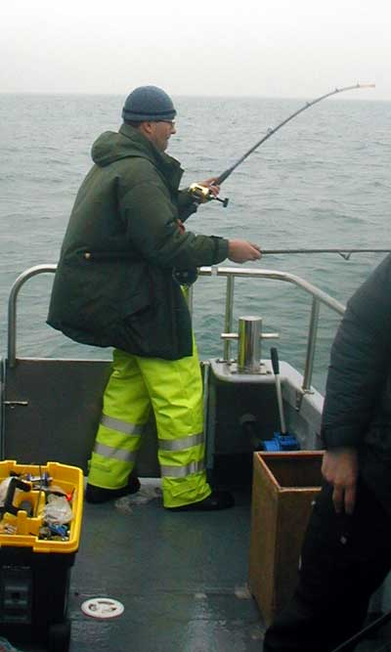
Two Rods Coster proves that it is possible to blank twice in one day.

Frank worked his socks off to make the day as pleasant as possible, little realising that with a crew of Really Wrecked anglers aboard, this was a futile waste of time. He’ll learn. His boat is extremely comfortable, stable, big and fast. And unlike certain skippers we know (you know who you are, Richard) he wasn’t afraid to give it more than 300 revs. The boat also sports an onboard tackle shop that is bigger and better stocked than even the world renowned Weymouth Angling Centre (i.e. it has TWO Okuma Classic 30s and four packs of hooks).
Despite all this, the fishing was not great, with only four cod and four pollack taken from several wrecks. The tide was very large, so the drifts were generally very fast, which may have contributed. On the other hand, it was more probably due to most of the crew spending most of the day trying to bag a new club non-fish record by hooking a friendly bottlenose dolphin that spent the day with the boat. Hugh, a new club member, didn’t help matters either, by losing three decent fish. As a coarse angler, he doesn’t have any boat fishing tackle, so Adam lent him his old gear. Excuse enough for the most experienced angler.

Back with the Smurfs
On April the 6th we managed just six anglers on a pollacking trip. And this at a time of year when the pollack are at their fattest and fittest. We should be ashamed. Luckily for those involved, Pete and Dave agreed to do a deal and went wrecking for just £300. Our thanks go to them, and to Stevie for being the inspiration for this generous act.
Pete headed for the sub, but spent most of the day on a couple of wrecks close by. Fishing the sub proved a waste of time, as a wreck netter had already covered her in lovely nets. Don’t you just love that?
It was a pretty good day overall, with more than 20 codling in the 4-8lb range, and a couple of pollack, coming to shads and other lures. Hugh finally managed to land a cod without losing three first, but then promptly succumbed to seasickness for the rest of the day – a great effort.
The day ended drifting the Mira fruitlessly, as the wind had got up quite suddenly in the afternoon, forcing the Smurfs to move closer inshore. But despite the weather and the disappointing end, not once was Stevie heard to moan about anything! What seems to have happened is that in trying to fix a broken lead boom, he somehow spilt a load of superglue on his lips. Perhaps the club would like to buy Stevie a family pack of Superglue to help in the future.

Beyond our Ken
Both the plaice and turbot trips went ahead this year, as the weather managed to be just the right side of too inclement to fish, and Ken was feeling brave. The plaice trip was on April the 10th, just four days after our previous trip.
I don’t really want to say too much about this trip, as of the six plaice to 3lb that were taken, Adam had four and Kim the other two. The only other detail worth noting is that several other species were taken, Tom and Mick did well with ballans to about 2lb, and I scored heavily with some serious pout. Sadly the god of angling did not smile so beneficently on Clive, who managed not a sausage. As you know, we don’t normally like to highlight failure in the newsletter, seeing how we’re a very touchy-feely, supportive organisation, but in Clive’s case, I think we can make an exception. So, I repeat. CLIVE FISHED HARD ALL DAY AND CAUGHT BUGGER ALL. As I’m sure you can imagine, the rest of the crew did not enjoy this one bit, most especially not his brother.
The turbot trip on the 12th of May was an improvement on our normal turbot experience. Although the morning yielded nothing on the mussel beds, drifting the shambles in the afternoon produced enough bites to keep the interest levels high, and three turbot to 6lb 14oz (the big one was Jari’s) and a cod of around 8lb that seemed to have escaped from a genetic testing laboratory far in the future. With its three heads, tentacles and ability to quote from the Terminator series of films, it was a bit unnerving, but I managed to ignore my qualms long enough to offer the fillets to a neighbour. Strangely the neighbour in question has started to glow in the dark and has constructed a vast cocoon where his garage used to be, but I expect he’ll get over it eventually.
Kim did magnificently too, catching two herring on feathers, when he was supposed to be catching bait. The brace included a record-equalling 5oz super-specimen.

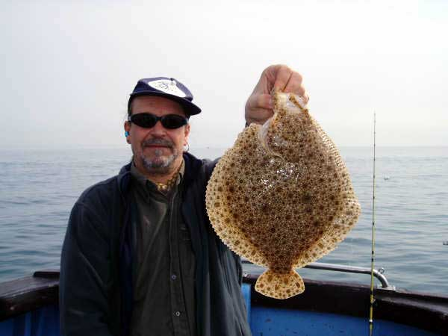
Adam manages to make a tiny turbot look like he’s holding it really close to the camera. Clever huh?

Four of the best
Between then and now, we enjoyed four more trips out with the Smurfs, two in April and two in June. Results were mixed, as you’ll see.
On Saturday the 15th of April, Adam had organised a trip with the Smurfs for his workmates. But when his colleagues realised that this meant spending an entire day out of their weekend confined to a small deck area with Adam, they dropped out in droves (apologies to the Smurfs, it’s a lovely big fishing area, but in this context, the Lake District wouldn’t be big enough). So four Really Wrecked members stepped nobly into the breach and went out fishing.
And what a day they had as their reward. This was in Adam’s own words “One of the worst trips we’ve ever had”. The day was rough, too rough to go offshore, and too rough to make fishing inshore pleasant, unless you catch lots of fish. Unfortunately that part didn’t go according to plan either. At the end of a horrible sloppy day on some rough ground, the score stood at one small smoothie to Adam, and another to Stevie. Well done to everyone who missed that trip.
The next trip was somewhat better. Nine days later, the wind had dropped enough to let us head offshore to drift a wreck or two. From the off we hit into a cod or two. Because of this most of the crew stuck to the hopper rig all day, though some people tried the long trace/redgill setup with varying degrees of success.
Without dwelling on the gory details, the final tally stood at 29 cod and eight pollack, with everyone on the boat catching a few fish. Biggest fish of the day was a creditable 16lb 2oz cod to Stevie, seizing this year’s Spotty Fish Award from Jari and his turbot.
The next trip was in perfect conditions, with hardly a breath of wind, blue skies and a decent tide for eeling. With slack water at 11am, Dave set the anchor after a couple of blank drifts and down went the cuttle and mackerel baits for the first conger session of the year.
As usual, there wasn’t long to wait before the first taps indicated hungry eels were about. A succession of small eels in the 15-25lb range were released at the side of the boat. For many, the high point of the day came when Adam noticed a bite. Or rather, would have noticed a bite had he not been snoozing/making a sandwich/fannying around with an end-rig.
Normally Adam would have struck violently far too early in the proceedings, wrenching the bait from the hungry eel’s jaws and sending it wriggling back to the safety of the wreck. But since he wasn’t paying attention, this time the eel had plenty of time to wolf the bait and look around to see what else there was on the menu. As luck would have it, there, right next to its first course, was another tasty morsel of cuttle, so it gobbled that one too. As this also belonged to a Really Wrecked angler, again nothing was done, and the eel was left free to roam around looking for the cheese course, and finally for the sweet.
At this stage, probably about half an hour after he first had a bite, Adam noticed something was going on and started to wind in. This created a bit of a chain reaction, as our ever alert crew began to notice that something was happening to their gear too, what with the eel that was attached to all their lines being heaved up from the bottom by Adam. So then Chris and Robin started hauling as hard as they could, which is not particularly hard in Robin’s case.
As is usual in these cases, most of the actual reeling in was left to Chris, who’s a big strong lad and, when he’s not pinning innocent club members to the wall shouting “Get the fuck ootie ma room!”, can use his power in a constructive and reasonably skilful way.
It was only when the eel came to the side and Dave stood waiting with the T-bar to release it, that the three anglers realised they were all attached to the same fish. I say three anglers, despite mentioning four courses before. This is because it was only at this stage, when four hooks were noted protruding from the poor eel’s mouth, that Jonathan shouted out “I’ve gone slack! Has someone tangled me?”

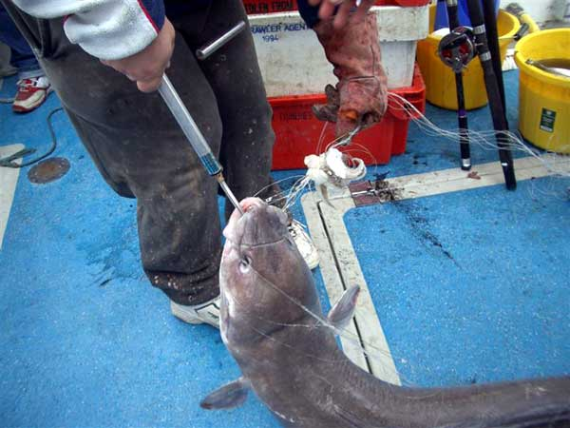
This conger shows that four into one does go. The greedy swine!

Jonathan and Adam then spent the best part of the rest of the day nobly untangling all the gear, rather than taking a knife to the whole mess, in order to prevent any of the tangled parties from losing about 300m of expensive braid. It was therefore particularly galling that with about two tiny twists left to untangle, Robin charged in slashing and hacking with his knife like El Cid slicing through the Moorish lines. In 30 seconds he had laid to waste to all their careful work and left everybody holding several short sections of line with their end gear rolling around on the deck.
All told, eleven eels were taken, the largest a 50 pounder to Tom, who’s now in pole position for the Really Eely Tankard, with another couple of decent fish of over 40lb.
With the tide picking up, Dave set to drifting, and the cod and pollack came out to play. White and orange shads on the hopper rig took most of the code, while firetailed jellyworms fished redgill style accounted for the pollack. Club Chaplain, The Extremely Reverend Woody (“Looks like a ZZ Top roadie” - Adam) managed his first cod and pollack, meaning a PB for both species. Nice one Woody! Woody is now offering pastoral care and spiritual guidance to all within the club and has assured me that by the simple laying on of hands, he can even exorcise the evil spirits that lurk within blue rods. On more secular matters, Neil and Tom got into a typically petty argument over whose pollack was bigger, with most people agreeing that Tom’s 12 pounder was slightly bigger than Neil’s eleven.
The biggest cod fell to Hugh, a very decent specimen at 19lb 1oz. This fish now leads the chase for the Spotty Fish Trophy. And so eight happy anglers made their way back into port that evening.

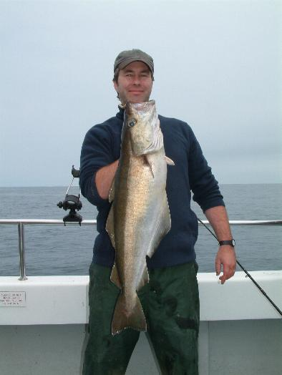
Neil proudly holds up a pollack only slightly smaller than Tom’s.

The most recent trip took place on Wednesday the 28th of June – yet another rearranged trip. The forecast said flat, but as it turned out the sea was just lumpy enough to give your knees that “much slapped against the gunwhales” feeling.
We drifted all day, as the tide was pretty big, and the eel fishing had been rubbish for weeks. The first wreck we stopped at had a very steep side facing the direction of our drift, and it was apparently festooned with wreck nets. So much so that on every drift someone snagged the wreck and lost their gear. In most cases, “someone” meant Phil Pepper, so for a while the rest of us were safe.
In the end, we had to drop down to half depth and only go all the way down when Dave shouted out that we were right over the wreck. In between snagging the odd cod was falling to orange shads on the hopper, so it seemed worth it.
Finally, having watched everyone else snag the wreck, I too succumbed to its charm and hooked something solid. Or almost solid. For a while it felt as though I was actually able to gain line, before it went solid again. Pete was called with the glove to break me off, but before he was able to do so, Tom, who was also into the wreck began to make progress with his snag too.
Then things started to get weird. My “wreck” actually took line. I began to get over excited. Could this finally be the angler fish I had dreamed of? Next, Tom’s hook slipped and he was free of whatever it was and was able to bring his gear back aboard, none the worse for wear. I was still pumping up a dead weight. Nearer and nearer the surface it came. The leader knot passed through my rod rings, and then we could see it coming up through the depths, but what was it?
It was fishy and not-so fishy, both long and odd. Another couple of pumps and the prize was mine… about 300 yards of five different braids, attached to three pirks, one 10oz lead, a jelly worm, a set of mackerel feathers and another trace which had a sad-looking doggie on the end. It looked just like one of Colin’s simpler rigs, though it couldn’t have been his because it lacked the huge slicing, spinning blade and string of Rapalas. The hook hold was highly precarious, with my hook only catching on the hook in the jelly worm. If I hadn’t maintained a tight line at all times, I would almost certainly have lost the lot.
Though I say so myself, it was a magnificent feat of angling, and is one of my proudest achievements to date, one of the few that compares to my goldsinney wrasse. This splendid specimen was weighed, photographed and the living part of it returned to the ocean, scarcely able to believe its luck, I would imagine.
As I’m sure you can imagine, the rest of the day seemed pretty ordinary after this, though we tried a couple of other wrecks with some success, and eventually returned to our first wreck for a few last fish. Our third lady member, Amanda, caught her first cod and pollack, and everyone managed to catch a few fish, giving us a total of 20 cod and 11 pollack.
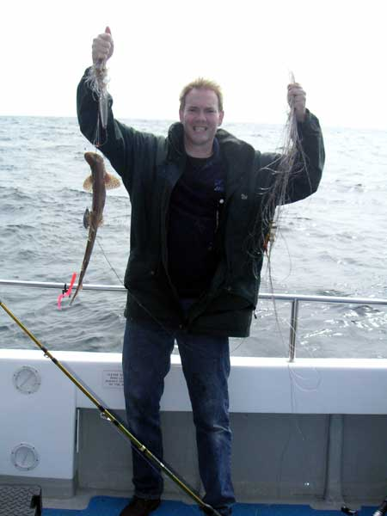
The superb record tangle, weighing in at 3lb 8oz – one of my proudest achievements.

Club News and notices
We’re off to Weymouth for the summer trip this weekend, so wish us luck. I’ll regale you with tales from the trip really soon (no, really Adam). The usual magnificent summer T-shirt is to be unveiled and if you’re not coming on the trip but would like to order one, please let me know by email (ben@reallywrecked.com) or by phone during the day (01980 556432). They cost £11 and are available in all sizes. Also available are the superb Really Wrecked polo shirts. These are dark navy and feature the Really Wrecked fish embroidered on the left breast. They’re a real bargain at £12. Stop me and buy one.

Remaining dates for the year
Take your pick from among the Newhaven and Weymouth delights below. Newhaven trips have an “N” and Weymouth trips have a “W” and are in a kind of maroon colour.
W Fri/Sat 7th/8th July Summer trip
N Monday 10th July Eels and cod or tope or bass
N Monday 7th August Eels and bream or bass
N Monday 18th September Eels and bream or bass
W Friday 29th September Rays/turbot/bass/tope
N Monday 30th October Eels and bream
W Friday 10th November Ballan wrasse
N Monday 27th November Eels and bream or inshore cod
N Monday 4th December Inshore cod

For all bookings, call Adam at work on 01306743744, or email him at a.frost@ukintpress.com. He’s waiting for your call.
That’s it from me until the next time, which will be very, very soon, I promise Adam. Enjoy the summer and GO FISHING.
Ben

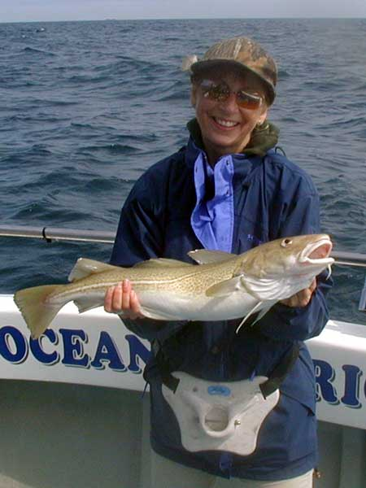
Amanda proudly holds aloft her first ever cod, on her first trip.

