W elcome to another year and another bloody newsletter. It has been a long time since the last one – six months in fact. You would have been forgiven for assuming the club had forgotten about you, and in fact it probably had. We aren’t known as the uncaring man’s bunch of bastards for nothing you know. So why am I disturbing you now, when you’ve got a nasty headache and a cold coming on, and loads of work to do and the bloody roof is leaking AGAIN?
To gloat, that’s why. Because this has been one of our best years ever in terms of trips and fish caught. And you missed out. If you didn’t miss out, then you have the committee’s permission to feel smug. Alternatively, you might consider that the role of this newsletter is less about gloating and more to remind you of the fun and fish that lie ahead by taking you back to the ones we caught last year, in the hope that winter’s miseries will melt away as you pick up the phone and call Adam to book up several trips.
Actually this year we didn’t just have more outings than before, we also had more bookings. Even more of you than usual were prepared to pick up the phone and hassle Adam over availability of spaces on trips, making him deeply grumpy about all the extra work. Well done.
And we have responded to your concerns. We are not regarded as the most responsive senior management team of a fishing club based in Southern England with “Really” in the title for no reason. Far from it, we are the committee of the people, and your concerns are our concerns, your desires are paramount, except where they unreasonably impinge on our own comfort and luxury, of course. So, in keeping with our touchy feely ethic, we have responded by going booking crazy this year, with literally thousands of dates reserved for fishing. Okay, not literally thousands, but twenty one, but even so, that’s a shedload of bookings by anyone’s standard.

Club News and notices

Annual Club Dinner
This year’s dinner is on Saturday the 27th of January, in the Crown Inn in Lewes. As usual, there is a trip booked on the Friday before, so that any of our more remote members can have a day’s fishing, as well as coming to the dinner. As there’s only a couple of weeks to go, please let Adam know you are interested AS SOON AS POSSIBLE if you haven’t done already. You will then be contacted with menu choices in the next few days. The cost is in line with previous years i.e. one arm and one leg, with perhaps an eye or a tooth as a tip.

The club dinner also means that it’s time to return your trophies, so we can get this year’s names engraved. Please get any trophies you have to Adam as soon as possible. If you have to post them, we won’t reimburse you because we’re very mean, but we will be very grateful. Send them to Adam Frost, UKIP Media & Events Abinger House, Church St. Dorking, Surrey RH4 1DF.

Subscriptions
And being that time of year, it also time for your annual subscription. This helps pay for the trophy engraving, postage of newsletters to those members without email, subscription to the Conger Club etc. If anyone knows of a good reason why he/she shouldn’t have to pay, keep it to yourself, and send me a fiver. It’s the best value in the business. The address to send it to is Ben Eveling, Club Skivvy, Really Wrecked SAC, South Mill, South Mill Road, Amesbury, Wiltshire SP4 7HR.

Plea for good stuff
Every so often I notice a certain “sameness” creeping into the newsletters. Now I know none of your could ever tire of my deathless prose, beautifully constructed plots and razor sharp wit, but maybe we need something else. Something badly written, ill-informed and unfunny, something by YOU. Maybe you want to tell us how to rig up for blonde rays, or perhaps something amusing happened which I failed to mention (though I doubt it). But whatever it is, just write it down and send it to me. We’ll probably publish it. Look, we even published the rantings of Andy Selby once, and there’s a man who makes Chantelle seem literate, urbane and witty. So please, send me all your rubbish, preferably by email (ben@reallywrecked.com), but you can also send it by ordinary mail to the address above.

Really Wrecked fashion
I have three superb 2006 T-shirts available, for the knock-down price of £9.99 which is a more than 9% discount on the original price of £11. These are a superb reminder of the fantastic English campaign in the world cup, but with that typical Really Wrecked Twist. There are two in size XXL and one in size M. It’s the perfect gift for the woman in your life (if you don’t really love her very much). All offers considered, except from Stevie.
Alternatively, you might want something timeless and perhaps slightly less red. For you, there is the Really Wrecked polo shirt. These are available in tasteful dark navy, with our marvellous logo emblazoned on the left breast. Say it loud, I’m wrecked and I’m proud. For just £12, you can. If your size isn’t in stock, we’ll order one specially for you.

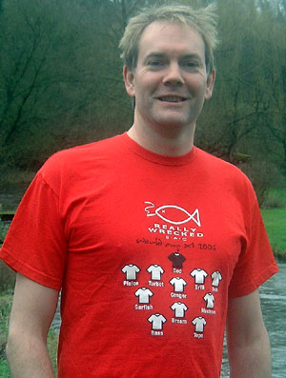
Don’t I look fantastic? Ben sports the latest must-have Wrecked fashion accessory – the 2006 T-shirt. The players are the names of fishes, in case you’re wondering, with Plaice, Turbot, Brill and Dab forming a flat back four.

Dates for 2007
Take your pick from among the Newhaven and Weymouth delights below. Newhaven trips have an “N” and Weymouth trips have a “W” and are in a kind of maroon colour.

N Monday 8th January Inshore cod
N Friday 26th January Inshore cod or offshore pollack
Friday 16th February Inshore cod or offshore pollack
N Monday 26th February Offshore pollack
N Monday 5th March Offshore pollack
W Friday 23rd March Plaice with Ken
N Monday 30th April Pollack or plaice or wrecking
W Friday 18th May Turbot with Ken
N Tuesday 29th May Wrecking
N Monday 25th June Bass or tope, or wrecking
N Monday 9th July Bass or tope or wrecking
W Friday/Saturday 20th/21st July Summer Weymouth trip
N Friday 10th August Bream, cod and eels
N Tuesday 28th August Bream cod and eels
N Monday 10th September Bream cod and eels
W Friday 21st September Blonde rays, bass, turbot and brill
N Friday 5th October Bream cod and eels
N Monday 22nd October Bream cod and eels
N Friday 2nd November Bream cod and eels or inshore cod and whiting
W Friday 9th November Big balllan wrasse
N Monday 3rd December Inshore cod and whiting

For all bookings, call Adam at work on 01306 743744, or email him at a.frost@ukintpress.com. He’s waiting for your call. The Sherlock Holmes among you will have noticed that the first trip has already been and gone. Well spotted, but I’ve included it just to prove to you that we did have 21 trips booked this year.

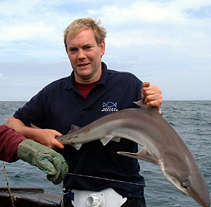
Me again – this time in the fabulous club polo shirt, with logo proudly displayed on the breast.

Catch and trip reports
There are seven trips to tell you about since the last newsletter, taking our total for 2006 to 15 outings! This is a record for the club, and even Sean can work out that this means we’ve had more than one a month.

Summer Weymouth trip
On the Friday morning, we all lined the quayside with an expectant air, ready for the off. All, except Robin, who was feeling a little under the weather. At first, this took the form of having to rush out of Andy’s tackle shop three times while buying gear, in order to avoid being sick over the lovely display of rods. We naturally assumed that it was rank stench of rotting hermit crabs and rancid ragworm that had turned his stomach, but in fact it turned out that he’d overdone it the night before, with a full two pints of beer before bed. This sorry tale could have only one ending, and while we loaded the gear aboard Bonwey, Robin unloaded his breakfast into the marina.
With these formalities out of the way, the A Team headed offshore in Richard’s new boat – Loneshark II. She’s a lovely boat, with a spacious cabin and plenty of cockpit space for us to fill up with all our crappy gear. Richard was obviously running her in, as he resolutely refused to increase the revs above 300rpm. Not be outdone, Ken had re-painted Bonwey, in honour of the B-team’s visit, and she gleamed shiny and blue in the morning sun as she quickly raced on to the plane once out of the harbour. The B Team waved to the A Team as Bonwey raced past Loneshark on the way to the Bill.

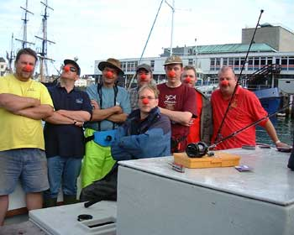
Poor Richard was suffering from a cold and a nasty, raw, red nose. This was our heart-felt response.

The A Team eventually made it to an offshore wreck, where Stevie set out his stall to tangle with every other member of the crew as often as possible. To do this, he made sure he was using less lead than anyone else and drifted and trotted his rig back through everyone else’s lines.
When not untangling their lines from Stevie’s, our heroes were catching plenty of cod and pollack to around 10lb, and the odd ling in the low 20s. When the tide slackened slightly, Richard put the hook down and everyone fell to eeling. Sixteen eels were taken in all, with the biggest estimated at around 50lb by the skipper, before it was brought aboard for weighing, where it turned out to be at least 62lb. I say “at least” because Richard’s scales only weigh up to 60lb, as he doesn’t like catching big fish, particularly eels. True to form, he spent most of the time when there were conger about, squealing like a girl and hiding away in his cabin.
Eventually, the tide slackened so much that the boat drifted off the wreck. It was at this point that Scoop hooked a pout and lazily winched it in with his rod resting on the gunwhale. It was only when it was on the surface that anyone realised it was a new record turbot at 11lb 10oz! Well done Scoop for a magnificent feat of fish Smedleying (Smedley, vb. To catch a fish without realising it is on the hook. After famous late 20th Century angler, Simon Smewing).

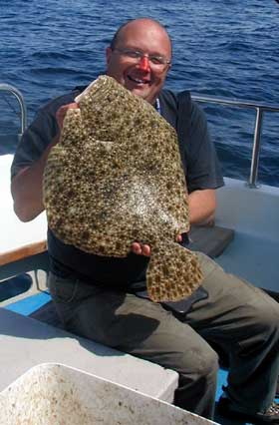
Andy’s splendid new turbot record, proving him the consummate angler. Note also the red nose – another tribute to Richard’s medical condition.
The B Team spent some time drifting for codling off the Bill, waiting for the tide to slacken enough to allow us to fish the three mile ground for tope. The codding proved amazingly unproductive, and eventually we headed towards the tope grounds.
When we arrived, the tide was screaming through, and it proved impossible to turn bites into fish. But then the tide slackened enough to allow us to use less than 2lb of lead and we started to catch huss to around 8lb, followed by tope, eels and bream. Robin, Dom (the Dominator) and I did well on the tope, with Nick coming good later in the day, Andy and Ian fished small baits and took 16 bream to two and a half pounds.
There now follows a technical part, non-anglers such as Adam, look away now. The tope bites were extremely finicky. They tended to play with the baits for ages, before picking them up properly and screaming off. Switching to fillet from flapper or whole mackerel seemed to result in less dropped fish, perhaps because the hookpoint was more likely to be proud, making it easier to hook a less-than-enthusiastic tope.

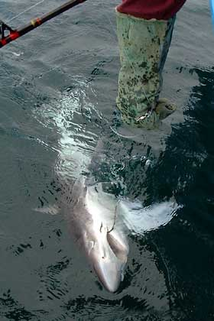
Ken’s gauntlet of power in action, releasing one of several 30lb tope.

Phil (Pepper, rather than Cook) hooked a decent huss of 12lb which did its best to take huge chunks out of his groin as he struggled to pose for photos with it. The tope were a good stamp too, with four over 20lb, and another three over 30lb, topped by a new club record of 34lb for me. This was an estimate, as Ken refused to bring it aboard for weighing. The capture was somewhat mired in controversy, as some members of my “team” refused to accept the validity of the estimate, and cast unwarranted aspersions on the manner in which the fish was released, claiming it simply fell off the hook, rather than being actively released. However, as the skipper had the leader in his hands and had been holding on to it for about 5 minutes while he made his estimate, by IGFA rules it counts as a record, so there!

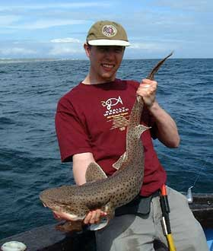
Grrrr! Phil struggles with a ferocious 12lb dogfish.

Only Neil (Rab) was struggling. Fishing alongside Robin, Dom and I, he completely failed to hook any tope at all and became progressively grumpier as the day wore on. Obviously we were deeply sympathetic to his plight and sensitive to his feelings and did not spend all day checking who had caught how many fish and discussing what a good battle they put up. Things came to a head when, late in the day, he finally hooked a fish that fought like a decent tope and which, at last, had the miserable sod smiling. However, despite all his huffing and puffing and praying, the fish fell off the hook within sight of the net, which provoked gales of deep and sympathetic laughter.
In all we had 11 tope to 34lb, four eels to 35lb, four huss to 12lb and 16 bream to 2¹/₂lb, making it perhaps out best day out with Ken (apart from plaice trips). Plus there was the joyful fact that my 34lb tope was now the biggest non-eel fish taken by a club member. The only thing to cast a shadow over our joy was the sad fact that Rab had blanked.
However, we threw off our deeply felt depression for Rab once back at the pub, and we were soon enjoying a tasty meal at the Ghurka. Once again, this all-you-can-eat Eastern buffet was like a red rag to a bull for certain members of the club, especially Stevie, who has never been known not to get his money’s worth.
Joining us were Charlotte, Richard, Becky and a variety of waifs and strays whom Becky had taken in, including Dorothy – nice to see him again – and Richard’s new crew “man” Mike, who received his “special” name during the weekend, becoming known as “Fanny”.
Also present was a friend of Charlotte’s called Sam. The presence of a single girl at dinner had a strange effect on some members of the club. Stevie bent her ear with a selection of anecdotes from his exciting life – it turns out he’s a pilot, you know. Nick gave the lucky lass an in-depth insight into his native East End, while Smed was beside himself, and rushed off to purchase a jumbo roll of gaffer tape and a length of carpet offcut, before inviting Sam to come and have a look round his van.

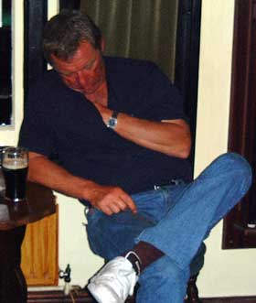
Stevie has a quick power nap to get over the excitement of the evening. This was only one of several pictures of Mr. Newham asleep that were offered to me. Is Stevie becoming the new Adam Frost, one wonders?

Day two, as you know, means the teams swap round. The A Team sped off to the productive ground marks with Ken, while the B Team chugged offshore in Richard’s slow boat to hell.
Now, as we all know, you can’t do it all in one day, but the A Team will always try. This time, they decided to start on the Kidney Bank for blonde rays (no surprise there), before heading to the three mile ground to enjoy some tope action, and to try to beat my new record.
On the Kidney Bank the tide was screaming through, requiring three pounds of lead and making fishing tough, even for the likes of Clive and Kim, though Adam showed how it should be done with a succession of fine doggies. Eventually the tide eased slightly, and three blondes to 12lb were taken, two by blonde ray fanatic, Clive.
After lunch, the team moved onto the three mile ground where, lacking the skill of the B team, the tope fishing was slow. Stevie in particular was finding the going quite tough. Unable to tangle so easily at anchor, he opted instead to snag on the bottom every drop. While retackling for the 50th time, he enquired how much lead was required to hold bottom. On being told that 1lb would do it, he promptly announced that he’d try 12oz instead. Down he dropped… straight into another snag. As he heaved and hauled on his rod, raging against the injustice of it all, Adam piped up with “Looks like 12oz is holding then.”
The silence was intense, as Stevie seemed about to explode. But before he could, Ken burst out laughing, and continued until he was forced to go and have a lie down in his cabin for a bit. For some reason, the sight of Steve having a hard time tickled him.
The B Team, meanwhile, reached the wreck a short time before slack water, but with enough tide to get a scent trail out to attract hungry eels. This worked to the tune of 17 eels in 45 minutes. Though there was nothing over 45lb, it was good fishing. Unhappily, Rab managed to catch a couple of eels, so the possibility of a magical “double blank” was cruelly snatched from him.
Once the tide picked up, we moved to a nearby wreck where the A Team had done so well on cod and pollack. For an hour, nothing happened, then finally cod started coming on orange shads, fished on a flying collar. Once the hopper rigs had been discarded, everyone started catching. The best fish was a 19lb cod taken by Phil, who, along with Ian ended the day with the most cod.
Finally we had a couple of hours fishing “the edge of the hole” for tope. Although we got there too late to get a decent scent trail going, we still managed two decent eels and Nick “bastard” Coster broke my lovely tope record, with a properly weighed 35lb 12oz fish.

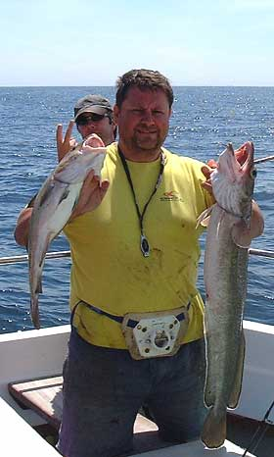
Ian shows off a nice cod and ling brace. Rab shows off his inner child.

The traditional curry was followed by a small prize-giving ceremony where awards were handed out to members who had been unable to attend the annual club dinner. Then it was back to the pub for drinks, before retiring to Ben and Adam’s room for a smoking competition. In this we were joined by the usual suspects, plus Charlotte and Sam. This meant we were able to enjoy the amazing and thrilling sight of Stevie attemping synchronised foot massages for both lucky girls.
This is apparently the seduction technique of choice for men of a certain age (or older), and while he probably wasn’t trying it on with Charlie (what with being invited to her wedding a couple of weeks later), there is a slight suspicion that he may have been with Sam. The fact that she turned out to be an independently wealthy heiress had nothing to do with his interest. Sadly, his charms were to no avail, and he took the gentleman’s way out by falling asleep on the bed behind the girls. He can and does now claim to have ended his Weymouth experience sleeping with both girls in a sensational three in a bed romp.
There was a vague plan for a trip to a nightclub, but this was somewhat kyboshed when it started raining. Then Chris applied the coup de gras by introducing some strange foreign cigarettes. I think they were Dutch, Peter Stuyvesant or Henry Wintermanns or something similar.
The last words I can remember hearing were “Try some of this” and then everything became a bit blurry. I don’t know how or when everyone left, I simply curled up in my duvet and waited for the strange lights and colours to stop and the huge bats to stop pounding against the windows. And that was that for another Weymouth summer trip.

Newhaven – July 24th
This was a pretty good outing, with most of the action coming on the drift. We managed 60 cod and four pollack to low double figures. With the anchor down, the eeling was slow. Colin led the small bait brigade, landing two of the three bream taken, and the only gurnard.
The highlight of the day was definitely Nick Coster’s splendid 70lb eel, which came almost at the last gasp, and which put him in pole position for the Really Eely Tankard. Is it my imagination, or are we catching far more and bigger eels than before? Our club record was 66lb for a long time, but since it was broken by a magnificent and modest angler whose name eludes me, we’ve had loads of sixties, several seventies and our record is now over 80lb.

Newhaven – August 7th
This was a lovely flat calm, sunny day and we decided to go toping on some banks off Burling Gap. We arrived at slack water, and once there was enough tide to anchor, we started to fish for tope. The doggies were first to feed, and then we hit the tope. Sadly, these were only small – up to 10lb.
The tide had just started running properly, when Dave suggested a move to a nearby wreck that held cod and eels. The fishmonger tendency in the club were seduced by the “c” word and agitated strongly for a move after some cod for the pot. The anglers among us were more inclined to stick it out now that the tope had started feeding, to see how it would fish later, but the fishmongers won the day.
At the wreck, the tide was running strongly with 2lb of lead required to hold bottom. There was no shortage of pouting attacking the baits, but despite a full cuttlefish hookbait lasting no more than a few minutes, Phil managed to land a couple of eels to 50lb. A late move to another wreck produced 12 codling and 2 pollack to about 8lb.

Newhaven September 5th
This was another lovely day, with a gentle breeze and lots of sunshine, with the tide on the flood for the morning, then ebbing in the afternoon. We fished a wreck about 12 miles offshore for the morning, but had only a few small cod to show for it. Baited feathers also took a few decent sized black bream.
Over slack water Dave took us over to one of his “big eels on the ebb” wrecks, where we baited up with cuttlefish, ready for conger. Nor were we disappointed, with good eels coming from the off. So hectic was the action, there were quite a few occasions when Dave had several eels to deal with on the surface at once.
There were a lot of pouting and bream on the wreck, so baits didn’t last long, but small baits did manage to pick out a few bream among the pout. Despite this, some of our small baits specialists had a go at eeling, with Paul Millmore catching his first conger. Afterwards, as he lay prostrate on the deck, gasping for breath and pleading to be carried off to bed for a little lie down, he did manage to say that he hadn’t realised quite how hard they pulled back. Welcome to the wonderful world of conger, Paul.
The stamp of fish was superb, with the smallest of the 30 fish taken going over 30lb, with six over 50lb and another three over 60lb, all weighed. Adam had been having a slow day, or as it is more properly known, “a standard Adam day”, as others caught eel after eel, while our hero could not buy a bite. But finally he felt the tap, tap, pull that means “eel” and he wound down into the fish.
After getting the fish up off the bottom, as per the manual, the conger decided that enough was enough and it went straight off, taking yards of line against the maximum pressure Adam could bring to bear. Indeed, despite winding the drag up as tight was it could go, the fish did not even slow down. This was clearly a HUGE fish, but with it up in the water, Adam felt he had a chance. But then came the sickening feeling of braid rasping on wreckage, followed shortly by the line going slack. Adam was gutted, and is convinced that this eel is easily the biggest he has ever hooked. Every single trip in 2007 (including Weymouth trips) is now scheduled to head for this wreck.
With the fishing so good, it was hardly surprising that Clive led the calls for an extra hour. Dave agreed, but as is often the way, the bites dried up. However, two or three eels were taken in this period, including a fantastic 75lb specimen to Colin, who was taking a break from breaming to try and christen his new rod. Well, he certainly succeeded in that, and he too now believes that there may be something in this conger fishing, particularly as he is now the provisional holder of the Really Eely Trophy.

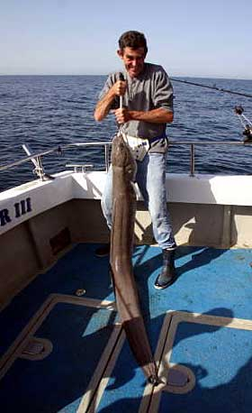
Colin hoists as much as he can manage of the 75lb of solid muscle that makes up the biggest eel of the year.

Weymouth September 29th
This was, in theory, an autumn blonde ray trip on Loneshark. The sea was fairly lumpy, and it was a bit of a surprise to be going out at all. But Richard is nothing if not foolhardy, unreliable and useless, so out we went.
We had two new members with us, Marvin Ellot and Rob Dickson and they were keen to see what the Really Wrecked Sea Angling Club was all about. Luckily on this trip, we had a pretty reasonable crew, so they weren’t exposed to the likes of Smed and Sean on their first outing. The worst they had to deal with was Kim and Stevie, and we mainly succeeded in keeping them apart, so I think we got away with it.
First up we hit the Kidney Bank. The tide was slow to start with and nothing much seemed interested in our squid and mackerel baits. Then the tide began to pick up, and with it, our enthusiasm. Sadly the fish didn’t share this, apart from the ever-friendly doggies, of course. Eventually, Marvin hit into something bigger, which had us thinking the blondes had come on the feed. But at the net, it magically metamorphosed into a good brill, which weighed 6lb 13oz, just 5oz below the club record and a very good start for the new boy.
It became obvious that the blondes were not going to play ball, so Richard suggested we head East to where the bass were feeding. Everyone was happy with this suggestion apart from Adam, who isn’t really interested in anything apart from cod, eels and big blonde rays. The journey there was interesting, as we crossed the tide rip with wind over tide on a lumpy day. It was exciting, to say the least, but Richard looked confident all the way. Then again, he is foolhardy, unreliable and useless, so we may have been closer to death than we realised.
Drifting for bass with sandeels is good fun, especially when the bass are interested, and they were. Most of the 20 fish we took were in the 3-4lb range, with a few bigger than this. Marvin and Rob did very well again, with Marvin taking the biggest, a nice fish of 5¹/₂lb.
As the tide slackened, Richard suggested that we head on to the Shambles and drift for turbot and brill. As the blonde ray fishing had been so excellent, we thought this was probably a very good idea. After a couple of fruitless drifts, distinguished only by the frequency with which we repeated the all-important phrase “If you think you’ve got a bite, you haven’t”, I had a definite “I know I’ve got a bite” bite which turned out to be a nice turbot of 6lb 14oz. To make matters worse, the very next drift I had a brill of 4lb 10oz.
Obviously this made me the most hated man on the boat, a title I usually claim, whether I catch well or not. This state of affairs continued for a good couple of hours, while nobody caught anything. Finally, both Stevie and Kim hooked turbot of around 3-4lb on the same drift, making them hate me slightly less.
It was at this point Kim worked out that if he caught a brill, he’d have a sandbank grand slam – the holy trinity – turbot, bass and brill on the same day. Then he asked me whether I’d caught a bass, which of course I had, I’m Mr. Bass, since you ask. So he then pointed out that I’d done the grand slam, which cheered me no end, until I realised that I was the most hated man on the boat again. Still, with a grand slam to my name, what do I care?

Weymouth November 10th
This was the long-planned trip after huge ballans. For this outing to work, it had to be late enough in the year for the weed to have died back, but not so late that the water was too cold, it needed a small tide, and for it to be fairly calm after a quiet bit of weather, so the water wasn’t too murky. Given all this, it’s hardly surprising that this trip had been cancelled on each of the last two years.
This time looked like being no different, as the forecast was pretty bad, and Richard didn’t want to encourage the Lewes branch of the club to come all that way just to be cancelled. However, with a bit of arm twisting, he was prepared to give it a go for local boy Andy Selby, semi-local boy Tom Fowler, and not really local, but not as far away as Brighton, boy, me.
Therefore, with Richard fishing, there would be four club members on the boat, making us quorate, so that any huge ballans would count as club records. Richard picked up the crate of hardbacks, which were to be bait. I was expecting 50p-sized common shore crabs (or perhaps slightly larger), but these were velvet swimming crabs about three feet across. As anyone who has ever handled a velvet swimmer will tell you, these bastards make even the biggest, nastiest common shore crab look like your girlfriend just after you’ve shown her the tickets for a surprise romantic weekend in Venice at a posh hotel that also has a chocolate whirlpool (if this last phrase turns out to be some kind of activity taking place between consenting males on Hampstead Heath, please accept my apologies, Rab, it was never intended to be hurtful).
The idea is to put half of one of these monsters on a size 5/0 O’Shaugnessy, with the legs and claws removed, and fish the whole lot on a single hook paternoster, with a short snood. Simplicity is the key. You’re going to lose gear, so you don’t want to lose a rig that took you an hour to tie.
We started West of the Bill, as the tide needed to slacken somewhat before we could fish the main target area just off the pulpit. As we dropped in, Richard made a bet with everyone for the first fish. Had he merely suggested the usual £1, no-one would have thought anything of it, but as he wanted a fiver a head, we knew something was up. It was Andy who twigged. “You’re fishing worm, you bastard!” he said, as Richard’s rod was soon twitching with a load of small wrasse bites.
As this was cheating, all talk of a bet was off, which was lucky, as he did land the first fish, and the second and the third, while the rest of us couldn’t buy a bite. After the first he switched to crab baits, so he could actually have won the bet fair and square if he wasn’t such a cheating bastard – a bit like Dick Dastardly, who had easily the best car, and would have won every single Wacky Race if he’d just driven as fast as possible, but was always too busy cheating to see this.
Luckily the first three fish were all under 2lb, so nobody cared. When he judged the tide was right, he made the move to position A in front of the pulpit. Shortly after he’d set the anchor, he hooked something much better, which after a short struggle, turned out to be a nice ballan of around 5lb. Not the size we were after, but definitely a decent fish. He then followed it with another of a similar size, so the rest of us were starting to feel left out. Luckily, I hit a decent fish too, and after a good battle, boated a nice 4lb fish. I followed this up with a smaller one, so Richard and I began to hand out tips and hints to poor Tom and Andy, who were entirely bite-free.

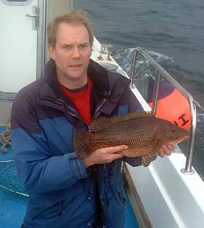
Just what this newsletter needed, another picture of me. This time with a nice ballan wrasse.

Sadly this situation did not last for more than another fifteen minutes, before both Tom and Andy hooked and landed wrasse of various sizes. As the tide slackened, the boat began to swing round quite wildly in the freshening South Westerly, making holding bottom and hitting bites quite tricky. We were still taking the odd fish, but we hadn’t had either the numbers or the stamp of fish we’d been hoping for.
Finally Richard decided it was time to head off and hunt for some tide, so he upped anchor. Or rather he would have done, had the anchor not fallen off the end of the rope. Richard tried to claim that the rope must have been dragged across and between many rocks as we swung around in the wind, and that it then frayed and broke. However, we know better. The poor bloke’s knots are simply awful, and now that he doesn’t have Dorothy or Fanny aboard to help him tie his knots, he’s all at sea.
After that minor disaster, we headed East of the Bill to fish on the drift, but we didn’t see another decent specimen. Finally, with the weather too rough for cowardly (as opposed to foolhardy) Richard to brave the bassing grounds, we headed to a point just outside the marina, where some squid were shoaled up.
There were lots of other boats squidding. This consists of working a special squid lure very slowly a couple of feet off the bottom. We’d had nothing but a couple of cuttlefish, when Richard said he “knew” where they were and motored a couple of hundred yards further inshore.
Straight away, I was into a good squid – they actually do a bit if you use light gear – and soon had the makings of a nice meal in the boat. Andy followed it up with a small squid, before he lost a huge specimen at the net, through a combination of over-excitement on his part, and slapdash net-work by Richard. How we laughed.
That was the end of the excitement for the day. We’d had about 30 wrasse to 5lb and two squid, so not bad for a shortened and rough day. It turned out one of the other skippers had had about fifty squid in ten minutes just after we left, but that’s what happens when you get the right man doing the job. Ah well.

Newhaven December 21st
This was the only fishable day in among weeks of wind and rain and there were a few cod about inshore, so Dave was optimistic. However, most people opted to fish for the plentiful whiting, rather than the rare cod, with the result that there wasn’t always a selection of large baits sending out waves of scent downtide.
It also meant that lots of whiting and pouting were taken, some of the whiting of a good eating size. However, it was the anglers who fished big baits, Adam and Nick, who landed the only two cod taken. Both fish were in the 8-10lb range, and were a just reward for trying hard all day.

The end
So you see, not only do we go fishing lots, and not only are we the nicest fishing club in the world, but we also catch lots of fish. To save you the trouble of totting it up, this year we had 194 cod, 63 pollack, 61 eels, 45 bream, 43 wrasse, 20 bass, 7 turbot, 5 ling, 2 brill, and a billion pouting, whiting and dogfish. That’s roughly four proper fish per person per trip, which really isn’t bad at all. So dust off your tackle and join us next year for more of the same, but more so.
Ben

