A s you know, the Really Wrecked newsletter is the home of truth in its rawest form, as well as of decency, even-handed justice, modesty, chastity and all other noble virtues. This is why I cannot lie to you and have to admit that’s it’s been a bloody awful year. In fact, it’s been worse than being marooned in a small life raft adrift in mid-Pacific surrounded by hungry sharks, with only Two Dogs for company.
We have booked up between two and five trips per month (counting re-arranged trips) every month since last August, and have managed just four trips in that time. Every year (except last year, which was quite good as it goes) we say “This is the worst year ever for cancellations.” Well, this year we’re smack on the money. It has been, and I do not exaggerate, windier than Adam after three days of eating only curry. And having spent the best part of three days under canvas with Adam under precisely those circumstances, that is fucking windy, I can tell you.
What can be done? Well, we could start being braver and insisting the Smurfs take us out when the weather is borderline. The trouble with that is, that unlike several years ago when a certain well-know skipper whose name rhymes with Fru Barnold was cancelling us on 2-3 occasionally 4, if we had forced the Smurfs to take us out each time there wasn’t a 6 in the forecast, we might just have managed to stay out at sea for a full day on one occasion, being thrown around by nasty lumpy seas, but for all the other trips we’d have been “back in by lunchtime” (© Steve Newham 1999) – the weather has been that crap. It’s usually ended up being worse than the forecast. Adam and I always check the weather on the day of a cancelled trip, and I’m sure you do the same. You don’t? You have a life instead? We don’t want you well-rounded types in here. Clear off and don’t come back until you’re as sad and OCD as the rest of us. Well, me and Adam, anyway. And Clive, of course.
And now, for the benefit of me and Adam and Clive, here are the reports of the two trips we’ve managed since the last newsletter at the end of last year.

Weymouth plaice trip
This trip was cancelled and re-arranged only the once, which makes it as rare as a smile on Les’ face. In fact, Ken did want to go out on the original date, with the wind forecast to be a gentle force 8 gale. Luckily we declined his kind offer, as that forecast turned out to be optimistic.
For this trip, we’d arranged a radical departure from the Weymouth norm, in that we were staying at an ordinary B&B and NOT AT THE SAILORS! Adam took this very hard indeed, initially threatening not to come down for the trip and saying he was going to join the Newick Nappy Hookers instead. Then he realised that this meant fishing with the likes of Les and Mick, so he came to his senses eventually.
No, instead of the luxury of 76 to a room at the Black Hole of Calcutta’s Return, and 600 to a bathroom, we were forced to put up with the privation of twin rooms and one bathroom to two rooms. And all for around the same money as we’ve been paying for the last few years. In the interests of fairness, and because I always send Helen a copy of the newsletter, I would like to point out to her lawyers that the Sailor’s does have advantages of its own, most notably the proximity to the fishing, the proximity to the bar, the ability to get a late drink, the friendliness and the Karaoke.
Anyway, the name of our luxury accommodation was the Warwick, and Pam was very welcoming (No, Stevie, not like that). Clive had given it the thumbs up (despite not actually coming on the trip) because “It’s got very good write ups on some of the angling forums I visit a lot” which just goes to prove that Clive really could do with getting out more. Sadly it only took Pam and her husband one night of accommodating the RWSAC to decide they’d had enough and were going to retire with immediate effect, so we’ll have to wait and see if the couple of who have taken it over are as angler-friendly.
But enough of B&Bs – what of the fishing? Well, after a fairly pointless morning drifting over a barren Shambles, the tide finally shifted around to let us start on the mussel beds, which is where the plaice were mainly concentrated. As usual, a wide variety of weird and wonderful spoon and bead-based monstrosities were lowered to the bottom, and, as usual, for some strange reason, they generally worked.
Stevie and Marvin caught the biggest fish, with Marvin’s almost reaching the magical 5lb mark, with a mighty fine fish of 4lb 12oz. Despite its size, you could sense the general disappointment among all bar one of the anglers aboard when it was weighed, as it failed to snatch Stevie’s record by a mere 8oz. Steve was naturally delighted, but he cleverly managed to disguise this by punching the air and yelling “yes!” repeatedly at the top of his voice.
One record was broken on the day, though, as Kim battered his brother’s feeble starfish best of 9oz with a magnificent specimen of 12oz. I have a sneaking suspicion that stealing one of Clive’s treasured records was more satisfying for Kim than all the plaice he managed to catch.
All in all, we had 20 plaice, making it one of our better trips after flatfish. Once again, I let the party down with one feeble fish to my credit. But I don’t care, because as everyone knows, plaice are a rubbish species, and there’s no skill involved in catching them.

Weymouth “turbot” trip
We were very much up for this trip by the time we finally managed to get out (it was cancelled twice, of course) on the 8th of June. It was partly the delay, and partly the fact that Les’ crew of plaice anglers, the Newick Hippy Poofters, had been out a few days after our plaice trip and while they had managed just the one plaice, they had managed several turbot, including two over 20lb! Bastards! Clearly if that lot could manage to catch fish like that, they had to be crawling up your rod.
We were staying at another palace of opulence, this time it was the turn of the White Cliff Guest House. Again we marvelled at previously unknown heights of decadence, including en-suite toilets! Actually the one in Adam’s and my room was more of an en-suite cupboard, that you had to enter via a secret door in the bottom drawer of the bureau, but if you sat on the sink with your legs in the toilet bowl, there was just about enough room to get your knob out.
Talking of which, there was some smutty and groundless speculation concerning Adam’s request to share a room with me, both from the likes of Steve (jealous spurned lover) and from our host and hostess. Quite why the idea that the club committee should want to spend a peaceful night away from the riff raff and common elements of the club is so amusing, is beyond me. It’s almost as though some, more old fashioned members of the club, actually disapprove of the love that dare not speak its name.
On board Bonwey it quickly became apparent that Ken was not going to take us out after turbot at all, despite the fact that Les’ lot had struck lucky. All the turbot had now gone, and had been replaced with hordes of tope, bream and bass. As Adam is allergic to bream and bass, we set off after tope.
Strangely, once we had anchored up at the tope grounds, for once, the tope did not disappoint. Indeed, once the tide had eased enough to let us hold bottom with less than 35lb of lead, we quickly began to take tope to the mid 20s, eels to about 35lb and huss. Although none of the fish were huge, it was good sport on light gear (12lb class for some, 20lb class for others and 80lb sharking gear for Adam).
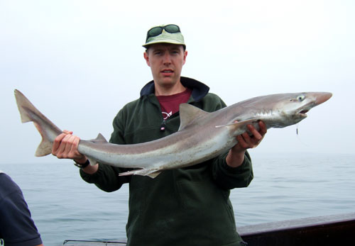
Phil holds aloft one of the tope which obliged on our turbot trip.

Clive also made a name for himself with a brand new club record. This time he claimed the vacant black-backed gull crown. Admittedly his prize was only tangled in the line, not hooked in the mouth, but if this were a serious criterion, 95% of the fish we catch wouldn’t count. Entertainly, when the bird came aboard for unhooking, Clive and the rest of the girls shrank back from the hissing, spitting ball of fury, a.k.a. a harmless seabird, leaving only Ken and I men enough to brave the ferocious assaults of the huge predator long enough to liberate it.
When the tide began to turn, Ken suggested a move to the bream grounds. This time, Adam’s cried of pain were ignored, and so we spent a pleasant couple of hours catching bream to around two and a half pounds. Stevie also managed a stray plaice, which cheered him up no end, and Phil Pepper did especially well on the bream. This was despite disobeying a direct order from Ken to tackle up with a running leger and size 2/0 hooks, as the bream wouldn’t take a bait on a paternoster with the tide running. Phil ended with five or six bream, all caught on his complex 18-hook (all size 2, by the way) paternoster.
Lastly, as if to prove that you can do it all in one day, we had a couple of hours gently drifting the Shambles, pretending that we were turbot fishing, but we knew there was no chance, and so it proved, although Clive, yet again, proved what a superb all rounder he is by smashing the edible crab record with a 3lb 2oz beauty. Once again he cringed weeping in the corner of the boat until the savage beast was safely corralled in a fish box by other, braver folk. So all in all, our day’s turbot fishing proved most successful, with 10 tope, nine eels, many huss, 12 bream, one plaice and an edible crab.

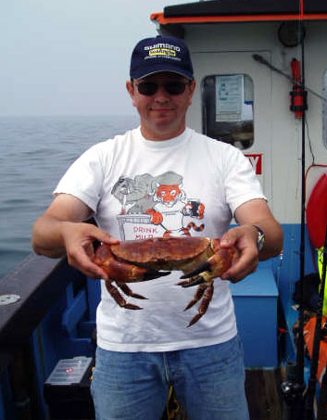
Clive tackles the vicious monster, having been reassured that the elephant tranquilizer has sedated it fully.

Club news
There’s all sort of exciting news to tell you...

Summer Weymouth trip
Due to incessant grumbling from certain quarters in the club, some of our number are not staying at the Sailor’s this year. Instead they will be ensconced in the Victoria Guest House, conveniently situated in Poole, or thereabouts. The details are as follows.
Address: 56/7 The Esplanade, Weymouth, DT4 8DG.
Phone: 01305 761438
Cost: £27/night payable on arrival. Bring cash or a cheque, as they don’t take credit cards.
Parking: There are three parking spaces available for a few quid a day, so it’s first come first served with regards to these. Others can put their cars in the usual free parking spaces on the far side of the river.
Accommodation: There are three twin rooms booked for two people each, and then four others are booked into “the flat”, which has two bedrooms and can sleep eight. Arrange yourselves as you see fit on arrival.

The real men of the party are staying at the Sailor’s as usual, so I expect to see a deep schism develop between the bastards in the Victoria and the rest of us.

Annual Dinner
This was a glorious success as usual, with sparkling speeches and sophisticated wit flowing like the Chateau Lafitte we were sipping. Despite the best efforts of the committee, we were unable to award all of the trophies to only those club members who attended (as we normally attempt to do), so certain awards may have to be disbursed at a later date.
The food was the best that the Crown has yet produced, with the puddings a particular triumph. Now normally a remark like that in the newsletter would mean the fare was inedible, but this time I actually mean it; the food really was very tasty. The evening ended in the usual drunken heap round at Adam’s, but for some reason, this year we were not allowed to watch Dickie Carr’s Groundbait Guide on video. I feel the club should insist that this annual tradition be reinstated at the earliest opportunity.

Come on you lazy swine!
I’m still waiting for contributions to the newsletter. I know for a fact that two club members have been fishing abroad in recent months, and one of us actually lives and fishes in Australia, so come on, let’s have your tall tales and exaggerated tarpon. Also, there’s a slim chance that one or two of you might have managed to pick up the odd skill over the many years we’ve been fishing together. So why not share your huge fund of knowledge with your fellow club members by writing an informative article or How-to.

Important news
This stuff is important, so please read it. Some or all of the below may or may not be contributions by club member or members unknown.

Vast bulk expected in Southern England
A Lockheed Starlifter is arriving at Heathrow at 6:30pm from the Southern Hemisphere with an enormous cargo of contaminated meat, rumoured to be Beef. Expect long delays on the M25 and M23, as the low-loader transporter and motorcade pass through. Licensed premises in the South East have started barricading their doors.

Club member catches 28lb haddock
The weight of the magnificent specimen was estimated using the Hodges-Tarpon method (similar to Duckworth-Lewis) in which the fish is meticulously measured for girth and length, and these measurements carefully compared to a species-specific chart before plucking an entirely fictitious and much larger figure out of the air.

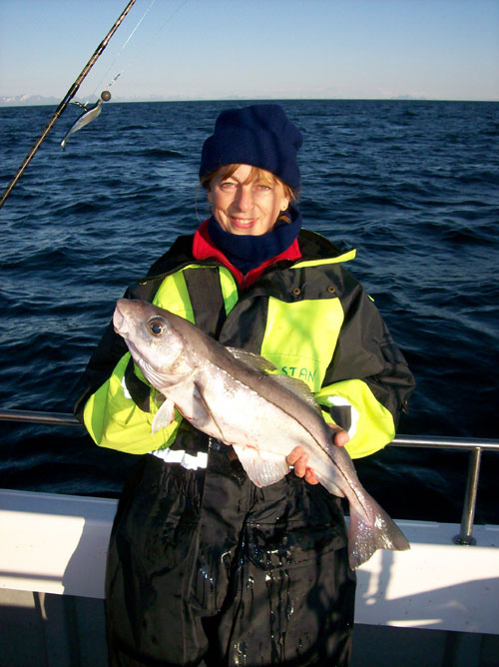
Manders and her 280lb world record haddock.

The odd couple
The owner of more than one canine companion is now a happily married man. He and his blushing Kazkak bride celebrated their union in the Crown last Tuesday and you weren't invited. I nearly was, but it turned out he'd rung the wrong "Ben" on his mobile. So congratulations to the pair of them. In breaking news, it has emerged that the "bride" is in fact a Soviet agent who is now being sought by the law enforcement agencies in connection with a huge shipment of polonium disguised as a wedding cake.

Lead theft and arson "linked"
A club member has returned from a trip to Scotland to discover his shed and children's trampoline burned to the ground. Police suspect arson and are linking the incident to a shadowy figure with a lank ponytail seen removing lead from the local church roof. A Barcombe associate of the wanted man, currently receiving hospital treatment for third degree burns, is assisting police with their enquiries.

Reward paid out for fish caught on WAC bait
After a 30 year wait, the £3,000 reward offered by Andrew Selby for anyone able to prove they had caught a fish using bait purchased at the Weymouth Angling Centre, has finally been claimed. Despite claims from a Mr. “A.S.” of Weymouth that the plaice in question had been starved of all food for six months before being dosed up on rohypnol and released close to the baited hook, extensive forensic tests do indeed appear to show that the fish did actually take the bait into its mouth, believing it to be edible. The fish died instantly, but was already hooked, allowing the prize to be claimed.

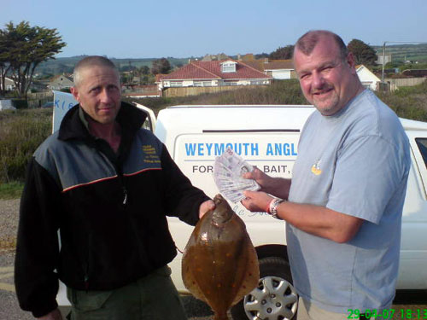
WAC owner A Selby grudgingly hands over the reward before lodging an appeal with IGFA.

Remaining dates for 2007
Newhaven trips have an “N” and Weymouth trips have a “W” and are in a kind of maroon colour.
N Friday 10th August Bream, cod and eels
N Tuesday 28th August Bream cod and eels
N Monday 10th September Bream cod and eels
W Friday 21st September Blonde rays, bass, turbot and brill
N Friday 5th October Bream cod and eels
N Monday 22nd October Bream cod and eels
N Friday 2nd November Bream cod and eels or inshore cod and whiting
W Friday 9th November Big balllan wrasse
N Monday 3rd December Inshore cod and whiting
For all bookings, call Adam at work on 01306 743744, or email him at a.frost@ukintpress.com.

That’s yer lot. Now stop bothering me and go and catch some fish.
Ben

