I t has now been so long since you got your last newsletter, that most of you will be beginning to doubt that you were ever a member of a fishing club at all. Certainly some of your attendance on club trips and events would suggest this. Rick, I mean you. And don’t think I’ve forgotten you either, John Ham. In fact, I’m not sure if you ever christened that Ugly Stik you bought in 2004 in a fit of misplaced enthusiasm, or possibly having mistaken it for an English longbow kit. The rod is clearly cursed, much like Beef’s blue rod, and the sooner you get rid of it, the sooner the curse will be lifted and you’ll be able to come fishing again. In any case, landfill is the best place for Ugly Stiks, so you’ll be doing yourself a favour. Don’t think I’ve forgotten the rest of you, either. Daniel, I’m talking about you as well. Just because you’ve never actually been on a trip, or met any of us, doesn’t mean you’re safe from a newsletter savaging. In fact it allows me more scope to let my imagination run riot over the gamut of your fictional transgressions.
Of course, some people have got a good excuse for their lack of participation. Sean, for example, taking to his role of the “Sick Man of Europe” with an enthusiasm bordering on mania, has now been banned from boat trips by his doctor and told to avoid being cooped up overnight in small rooms with Adam, in case the vibrations from Frost’s nasal symphony set off a chain reaction causing all Sean’s bones to liquefy and his body to turn into a vast gelatinous mass. Or has that already happened? Despite this, at least Mr Geer had the decency to show his twisted features at the annual dinner where he gave a charming after dinner demonstration of joint ossification and galloping osteospondylitis, but more of that later.
The point is, despite the lack of low grade bollocks and out of focus pictures arriving in your inbox on a regular basis, you really ought to get off your arses and come fishing. You know you want to. And much as I love setting off on yet another trip with sodding Stevie, that bastard Two Dogs and bloody Marvin (and if you say “who?” it proves you haven’t been out recently), it would be lovely to see some of you other folks. And if I have to spend one more minute in the company of the grinning fool, Colin “Christ Alive” Pearce, I swear I’ll sell all my tackle and take up golf.
So anyway, no, this is not some kind of Nightmare on Ken’s Boat, part 34, in which Freddie Kruger bores his victims to death with elaborate filmic metaphors, nor is it some evil plot to get Celine Dion and Bryan Adams to record a duet in your living room, while you are tied to the armchair, it’s just a newsletter and a plea to come fishing. We miss you and Adam wants new people to shad with.
As it has been ages since the last newsletter, that ought to mean I’ve got loads of trips to tell you about. Those of you still looking for an excuse to avoid coming fishing, even after my heartfelt plea, will probably be expecting me to say they were all cancelled. But no, thanks to the tireless and thankless efforts on your behalf by the hard-working and extremely good looking committee, many of the cancelled trips were re-arranged, meaning that in theory, there are 12 trips to tell you about. But I can’t do that to you, as it would mean stretching this thing beyond even the legendary patience of fishermen. Besides in most cases I’ve completely forgotten what happened and my shorthand notes are entirely incomprehensible to me. What the hell could I have meant by “Twlve cd, sx pllck, twnty4 cngr. Stvie cmplte wnkr, Adm cnt.”? It’s totally baffling.
Instead I thought I’d give you a few fishy totals, so you can reassure yourself that we still catch fish, and to illuminate things with whatever highlights I’ve managed to retain.

Last year’s Weymouth summer trip
Yes it has been that long. I confess. I am scum. In terms of the fishing, the B Team had a goodish first day with Ken, catching a bass in the rips (which on Bonwey meant a 30 second drift and a six hour steam back uptide), lots of bream and huss on the mussel beds and the odd conger. Their second day included lots of eels including both the 48lb winners of the Really Eely Tankard, and a mass of tope, pollack and a few more bass.
The A Team did well with Richard, catching tope, eels and bass about 8 miles offshore, and then followed it with a rubbish second day when they had one plaice and a bream. Serves them right. Adam though, had a trip to remember, bagging a magnificent 7lb 5oz record stone. This provoked much debate as to when a stone becomes a rock. We eventually decided that a stone is a stone until it weighs 14lb (a stone) at which point it becomes a rock. There’s really wrecked logic for you.

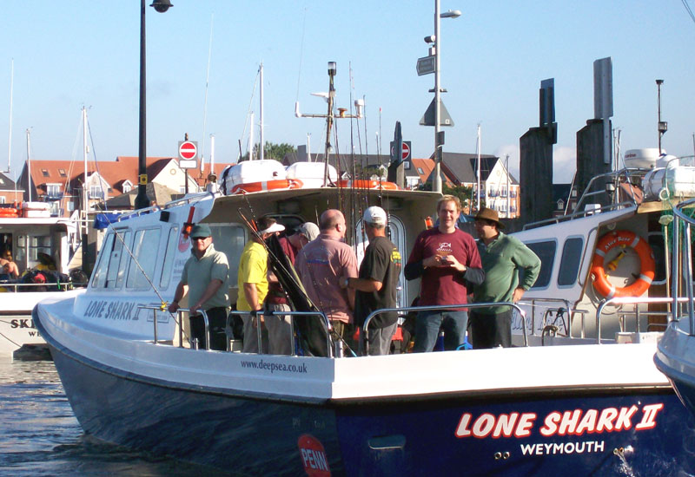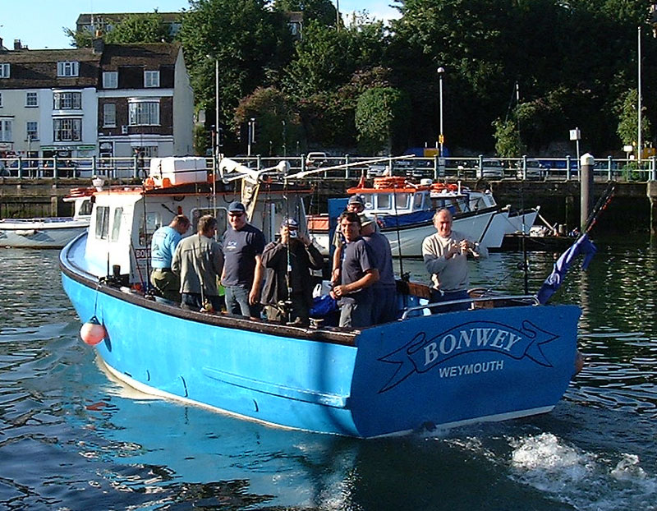
The two finalists from the “Eight wankers on a boat” national contest.

2007 round up
In the five other trips last year, we had a grand total of 87 conger to 45lb, 100+ cod to 17lb 5oz (more on that fish later), 12 pollack, 30 odd bream to 3lb, one bass, several gurnard, many dogfish and many more pouting. Colin managed yet another record with a superb, hard fighting scallop weighing a doughty 7oz, so well done to him.
The cod was particularly memorable partly because it was the first proper fish for a new member – a friend of Mick Deacon’s called something like Al Anne or some other strange mixture of a boy’s and girl’s name. Our story starts when he managed to get himself in a fearful tangle and Mick was very kindly helping to sort things out. Then, on one of Mick’s seven rods, there came a confident bite. Mick returned the tangle to Al with a cheery “Sort it out yourself, you workshy ladyboy” and struck at the bite.
Using all his skill and judgement, he quickly decided the fish was a strap conger and handed the rod to Al so he could land his first decent fish. Imagine his disappointment then when the “strap” turned out to be a superb rough ground cod of 17lb 5oz. While the crew buzzed excitedly round the deck, taking photos and congratulating the rookie on his catch, Mick noticed another bite on one of his many other rods…
Careful not to be too generous with this bite, he struck and wound in what felt like a heavy, if somewhat relaxed, fish. Imagine his joy and surprise when a huge lobster of around 10lb (some £80 at least at today’s prices) broke the surface at the back of the boat. But such was the pandemonium on deck, what with the cod being weighed, photographed, fingerprinted and carbon-dated, that the net was a very long time coming. So long in fact, that just as it appeared, the lobster gave up waiting, let go of the baited hook and sank slowly back into the depths, accompanied by a howl of anguish from its captor. They say that on still nights you can still hear that howl off Seaford Head, ululating painfully over the slow sound of the surf.

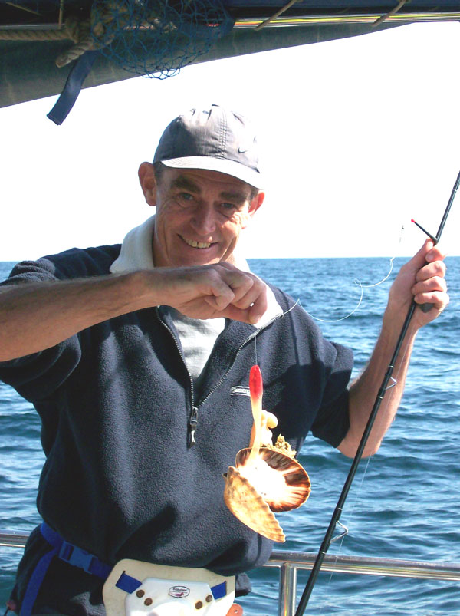
Colin’s shad-caught record breaker – that noted predator, the vicious scallop

2008 trips in brief
Though not strictly a “trip” as such (though some of our acid casualty members might disagree), I’ll start with an account of the annual dinner. While the brilliance of Adam and my performance in handing out the trophies, in some cases even to the right people, will live long in the memory, and no-one who saw the new pint-sized Ian Gray will ever forget his shrunken and shrivelled appearance or the clothes that appeared to have been contructed to accommodate two of him, this year’s dinner will be chiefly remembered for one thing and one thing only – Stevie’s arse.
It was towards the end of the interminable rabbiting that is the awards ceremony, that Stevie made it clear that he had something to say. So in keeping with our democratic traditions, we ordered everyone to remain silent and to listen to what one of our oldest members had to say. He started well, praising the efforts of the committee, and remarking on how much work we put into the club, clearly demonstrating the commitment and, dare I say it, love we show to you all.
So far, so good, but then it all got a bit weird. Stevie turned on the club members and asked them if they thought they showed the club and the committee enough commitment and love. As this question registered with his rapt audience, he began to fiddle with his trouser buttons and fly. Since he was standing next to Adam and I, and we were both seated with our heads at about trouser fly level, I think it fair to say that the committee were beginning to become quite concerned as to exactly what form Stevie’s demonstration of love was going to take.
Things then took a turn for the worse. Before you could say “Gay orgy” Stevie’s trousers were down, he had turned to present his arse to the audience and then proceeded to moon the stunned onlookers. There was a, frankly appalled, moment of silence before Stevie directed our attention to a small blue tattoo on one cheek, which turned out to be a tasteful and accurate depiction of the club fish, smoking as is his wont. The sigh of relief could be heard in Worthing, and the laughter that followed lasted longer than the awards ceremony. I can honestly say that this is the best and funniest thing Stevie has ever done.

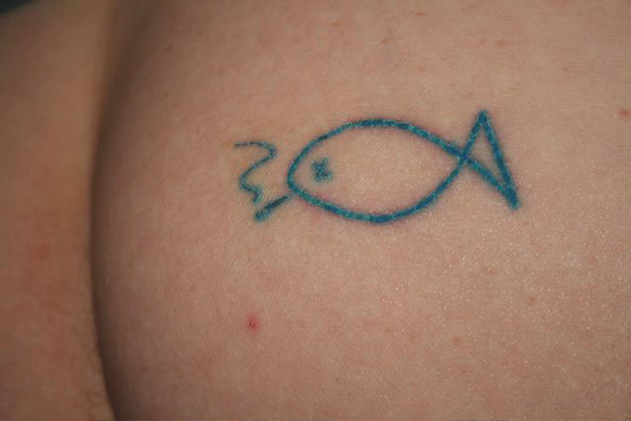
Those of s nervous disposition, look away now. The best thing Stevie has ever done.

Other than Stevie’s arse, this year has seen a further six trips, some of which I was awake enough to be able to remember in some detail. Two trips proved highly successful drift fishing trips, with over 120 cod and pollack (mainly cod) taken. On both trips, while everyone caught, a combination of blue Tempest lures, lots of lead (12oz – 1lb) and either Kim or Colin doing the fishing, proved the killing combination. The later of these two trips showcased the considerable conger catching skills of Robin “Does it have a name?” Eyles, as he somehow managed to trash, yes trash, a TLD on a 5lb strap which took him well over 20 minutes to land. No-one in the history of angling has ever managed to trash a TLD before, and even a Fladden can cope with such a minute eel. The man has a special talent.
On the same trip, one of our biggest cod for several years came to Chris Grant’s cuttle bait, first drop while congering. It’s amazing how often the first fish taken at anchor is a cod, after which no other cod are taken on baits. This fine fish weighed 23lb and has to be a contender for spotty fish of the year.

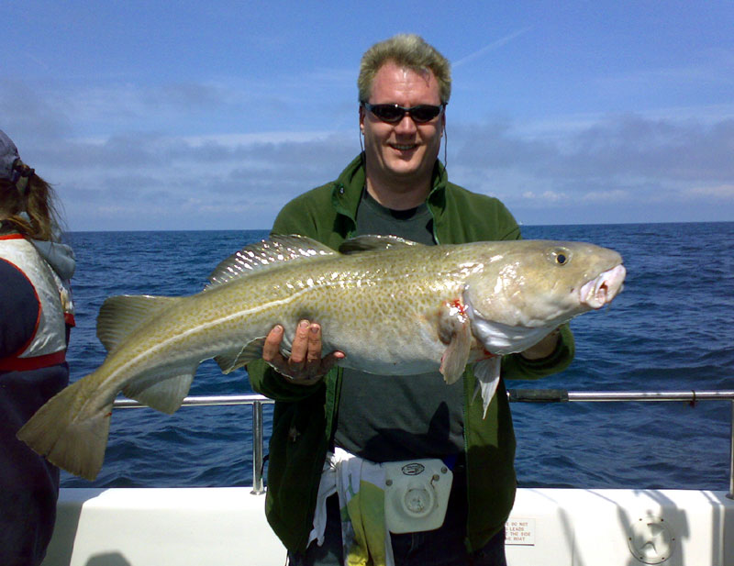
Chris and his superb 23lb cod – up for spotty fish of the year, despite being less spotty than Stevie’s arse.

Plaice trip
Regrettably, I was unable to attend this year’s plaice trip, as I was on a family holiday in Cuba. Once in Cuba, I managed to contract pneumonia, which kept me well away from the huge tarpon crashing out of the water in the canal at the other end of the town. Despite spending my entire holiday in bed producing enough snot to fill the Carribbean, I still had a better time than if I had gone on the plaice trip. Two plaice were caught, one on the first drop down, and one on the last, and in between all there was to do was to listen to Stevie telling Ken he didn’t know his job properly. Enough said.

Turbot trip
This trip very definitely ought to have inverted commas around it, as the number of times we’ve actually caught turbot on the turbot trip can be counted on the fingers of one finger. However, we always start off with hope in our hearts, and who knows? Maybe this year was going to be different. The main difference was that for this trip, the Happy Hookers of Newick had challenged us to a flatfish competition and had even provided, at great expense, a trophy for the winners. The rules were simple, the flatfish representing the biggest percentage of the national record won the cup for the captor’s team.
It got off to a flying start when Stevie asked me to collect his Penn reel from the Weymouth Angling Centre, where he’d left it for a quick service. I went in, and, having bought all the bait etc. as you useless, helpless, selfish bastards always expect me to do, asked for and paid for Stevie’s serviced reel – a snip at around £50! This was a particularly good deal because that’s about how much they go for on Ebay. Ask Stevie for the precise figure, I think he tattooed it into his other cheek with a rusty 8/0 during the trip.
The cost of the service proved something of a distraction for our tight-arsed hero. He spent at least 80% of the day on his mobile trying to complain and demand his money back from Lord Selby, who was in the Czech Republic at the time, doing a deal for a consignment of knocked off ABUs with some Albanian crime overlords.
Obviously with Steve’s reputation as a major charitable donor and always first up at the bar, the size of the bill caused no amusement whatsoever among the rest of the crew, made up as it was, of some of his closest friends. There were no appalling and repetitive jokes concerning that thing you do with a tennis ball and racquet when it’s your turn to start the rally, nor any comments on how well people were treated in various hotels around the world. And remember, these extremely low quality jokes that were not made and to which I am not referring, would have been the best of those being made, had they in fact been made. And they would probably have been made endlessly, so it’s jolly lucky they weren’t made, otherwise I expect Stevie might have got a bit totally pissed off with Adam and me, or whoever wasn’t making such infantile and crap jokes.
The one good thing to come out of this sorry saga is that at least the board of Penn will now be able to afford a bit of bubbly at the annual shareholders meeting. They like a bit of bubbly, do the shareholders.
But that wasn’t the highlight of the day, and it wouldn’t have been even had it actually happened. The highlight started when we took on board an exhausted stowaway, in the form of a tiny lesser spotted flycatcher, which had migrated all the way from central Africa and looked fit to drop when it flopped aboard Bonwey. Marvin was the first to adopt the waif, giving it water and milk and a few crumbs of biscuit. While nursing it, he became extremely possessive, threatening to punch anyone he caught staring at his bird, which he had christened Orville. Eventually Orville stopped shivering uncontrollably, and found the strength to start hopping around the boat, stopping to peer merrily into tackle bags, perch on seats and to snuggle up against various items on deck whenever it wanted shelter from the biting wind.
And so it remained, safe among its protectors, until Stevie became terribly excited by the only flatfish of the day and in staggering about the deck in joy and elderly incompetence, managed to crush the poor wee thing with his hobnailed size tens. To have made it all the way from Africa only to end its days under Stevie’s jackboots… The stunned silence as we watched the drama unfold will stay with me forever and those who were not there cannot begin to imagine the sobs that wracked poor Marvin’s frame as he grieved for his new best friend.
It was only after we gave the sad little bundle of fluff a decent burial at sea that we remembered that Stevie has form here, having previously dispatched an innocent conger eel by stabbing it through the heart. I’m not sure, but I think I even heard him mutter as he staggered, apparently randomly, over the deck with the prize plaice, “I’ll teach you fuckers to get sucked into my jet turbine intakes.” The prosecution rests. The plaice may have gone some way towards making up for the cost of the reel service and the painful jibes which did not result from that, but the rest of the crew will never forget our brave companion and how he was cruelly cut down in his prime.
However all this was instantly forgotten when we returned to port to find that Stevie’s 3lb 12oz plaice easily beat the Happy Hookers only fish – a 4lb odd turbot. This meant that the giant, bejewelled, diamond and emerald bedecked golden cup was ours, proving for all time that our fishing club is better than theirs and that we are better men than them. Even if we did have to rely on Psycho Steve to do it. Anyone wishing to view the trophy can do so for the next couple of days down at Smiths Pawn Shop on the High Street before it is smelted down for its gold, platinum and expensium content. Or to make leads for the Weymouth trip.

June’s an eventful month
An early June outing proved exciting in almost every possible way. Initially calm weather turned snotty and lumpy (a bit like me in Cuba), which was made all the more thrilling when the Smurfs throttle cable broke, forcing Nick to have to regulate the speed by sitting on the air intake, a job which put a smile on his face that lasted all day. Okay, I made that last bit up, but I expect Nick would have liked it had he been asked.
The Alton Towers experience did not appeal much to the Reverend Woody, who obliged the club committee by making an early bid for the Breakfast Revisited Shield. As most other club members who can be relied on to throw up have unaccountably stopped coming fishing with us, it’s a relief to have a solid contender for this trophy at last.

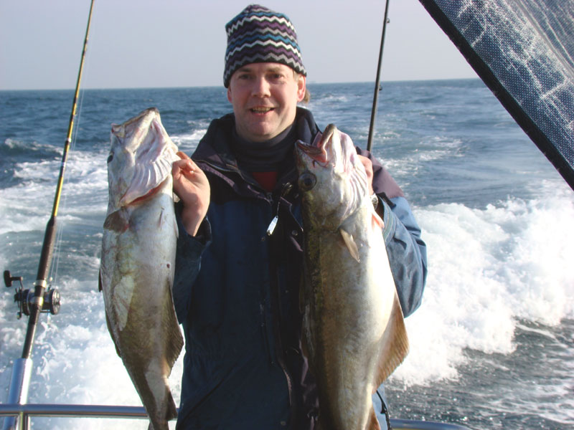
A brace of nice spring pollack and an early bid for C*nty hat of the year

Nick Coster also made a bid for an award with a hybrid killer gear/flying collar rig. This featured three shads and a pirk, killer gear style, but fished on a running leger with a long trace, gilling style. In the hands of a Mick Deacon or a Jonathan Barrett, this could prove to be the ultimate tangling rig.
Other than that, 35 cod were caught and 10 pollack, with everyone contributing to the total. Despite this or perhaps because of it, Stevie managed to remain thoroughly miserable all day. So all in all, a perfect result.

And later in June…
This trip didn’t necessarily start as well as can be expected, as I managed to forget something on my way down to Adam’s the night before we were due to go fishing. So when I woke at 3am in a cold sweat, with the awful realisation that I was in fact in Sussex, things got worse as I also realised I had left my reels behind in sunny Wiltshire. Those of you with long memories, or who are merely elephant-shaped (you know who you are), might recall a superficially similar incident in which Andy Freeman forgot all his rod butts on the way down to Weymouth and then forced Chris Grant to turn round at the outskirts of Dorchester to return to Lewes for these important items. This spectacular piece of forgetfulness prompted the creation of the Andy Freeman Cup for Blind Stupidity, one of our most over-subscribed trophies.
Some might be tempted to draw parallels between the two sets of circumstances and possibly to foresee some kind of insane award nomination for me. Let me point out to such folk the striking differences between the two. Firstly, I did not forget a single rod butt, nor force anyone to drive hundreds of miles out of their way to make up for my mistake, and lastly, in the prior incident, no member of the club committee was involved, making it fair game, as opposed to the more recent situation where, because of all of the complex planning involved in every club trip, a minor oversight occurred, for which no-one suffered but myself.
And boy did I suffer. I was forced to use Adam’s “B” reels, and those of you who have taken a moment to examine the mackerel scale, slime and rust encrusted corroding hulks that make up his “A” reels, can imagine what he lent me. The ABU 7000 I used for gilling was clearly an early bronze age relic, without such luxuries as a functional drag or free spool, and which boasted a full complement of almost 15 yards of braid. This was attached to the 200lb backing mono by the largest knot you’ve ever seen, which not only blotted out the sun for much of the day, but which was also much too large to fit through any of my rod rings. Luckily though, when this Gordian Grinner had been persuaded through the rings, there were a further two backing knots, as it became clear that Adam had used up several old spools of 1970s Bayer-Perlon to fill the reel. Thanks Pal.
Now, I don’t want to seem ungrateful, but if something similar ever befalls you, please bear in mind before setting off to fish that a day in the office or spent shopping with your spouse is vastly preferable to a single drift using Adam’s 7000, waiting for a take and for the drag to seize completely, before finally yielding 100 yards of line in one sudden jerk, forming a beautiful birdsnest, which still manages to be approximately half the size of the leader knot. A bad workman always blames his tools, but a sensible workman avoids using Adam’s “B” reels.
All this meant that while other around me were catching cod after cod, I remained fishless and permanently tangled. When I tell you that even Robin “Fuck me, he’s hopeless” Eyles was giving me a battering, you’ll understand how bad it was. Eventually class told, and I managed to bag a few cod, much to the entire crew’s relief, as they were starting to work out that while taking the piss out of me is good fun for a while, having a bad tempered wanker on the boat all day makes things less jolly. Another reason to ban Stevie from every boat except Bonwey.
Eventually we settled down for some serious eeling. This time I had the enormous privilege of using Adam’s “A” gear, while he teamed up a new Ebay-bought Fox reel with his 1960s 80lb class rod. This is the outfit he’s going to use from now on, with 80lb braid and all, just in case he ever meets up with the submarine masquerading as a conger that snapped him up after hours of fun a couple of years ago.
Let me state right away that Adam’s “A” gear is much better than his “B” gear, but if Adam ever takes the piss out of your shitty tackle in future, just point out to him that at least your Shakespeare/Okuma/Fladden/Euroboat was shit when you bought it, and you didn’t have to embark on a decade-long campaign of maltreatment to reduce Penn or Shimano’s finest to the state they’re currently in.
Unfortunately, Adam never got the chance to test the power of Fox’s cardboard drag and polythene gearing, as for once, the eels gave his baits a miss. Everyone else had a few, topped by a fantastic PB for Stevie with an eel of 70lb. After last year’s pisspoor 48lb winners of the Really Eely Tankard, this year it’ll take something pretty special to wrest the trophy from Stevie’s iron grip. This is only the fourth eel of 70lb or more taken on a club trip and as the scales swung between the extremes of 2lb and 70lb (including net), Stevie’s cry of “Yes! It’s a seventy!” left no-one in any doubt as to its true weight.

More pleading
So with the jolly stories out of the way, let me get on to the serious purpose of the newsletter, which is to cajole you into signing up for the Weymouth summer trip. For some reason the best trip of the year, which takes place in eight days time, is three people short, meaning we are an unlucky thirteen instead of a healthy sixteen. So now’s the time to show the love and commitment of a Stevie by signing up for the trip. You’ll catch fish, have fun with your mates, get to see Stevie’s tattoo at first hand and return home fully satisfied with all aspects of your life. Call Adam now and book.
And another thing, while we’re on the subject. We are about to embark on another round of lead making, as Jonathan has managed to lose all of last year’s. This means Adam desperately needs your lead, as the gold from the Flatfish Trophy will only go so far. Please call him RIGHT NOW (01306 743744) if you have any lead you can spare. Also call if you can spare a little time to help out with the lead making itself.
Once you’ve done that, please feel at liberty to choose any other trips from the list below. We look forward to seeing you. You may take that as a threat if you wish.

- Friday/Saturday 25-26th July
WEYMOUTH Summer trip
- Monday 25th August
NEWHAVEN cod, eels and bream
- Friday 12th September
NEWHAVEN cod, eels and bream
- Monday 22nd September
WEYMOUTH rays, bass, turbot
- Monday 13th October
NEWHAVEN cod, eels and bream
- Friday 14th November
WEYMOUTH big bold ballan wrasse
- Friday 21st November
NEWHAVEN cod or eels and bream
- Monday 1st December
NEWHAVEN inshore cod
- Monday 15th December
NEWHAVEN inshore cod

Right, that’s about all for now, get yourselves in gear and get booking.
Tight lines and/or slacks (depending on age),
Ben

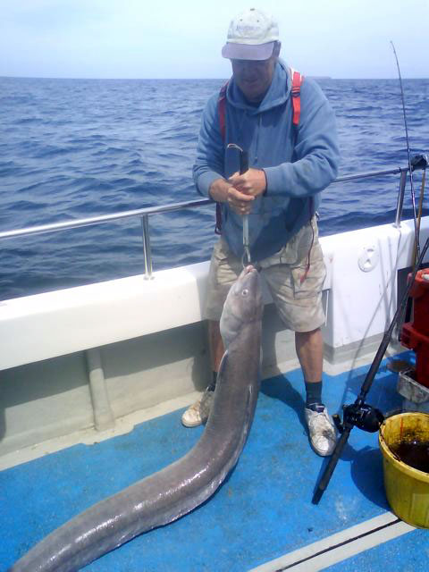
Stevie struggles to get to grips with his seventy. Unaccountably, the fish went back alive, rather than being murdered by Killer Newham.

There’s a PS to this newsletter. People keep sending me random pictures of themselves with fish not taken on club trips. Admittedly some of these are rather fantastic fish, so after years of pretending they don’t exist, I’ve decided to include the latest two in this newsletter. If any of the rest of you want to share your personal angling triumphs with the rest of the club (aka gloat), send me the pics by email, and unless this policy has changed, I’ll stick them in if I like the look of them.

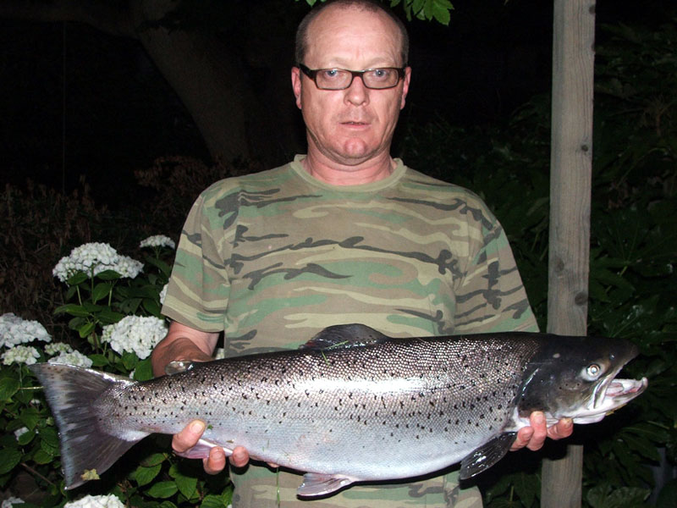
Mick caught this amazing sea trout from the Sussex Ouse on a spinner one recent evening. The fish weighed a colossal 13lb and is one of the best to come from the river.

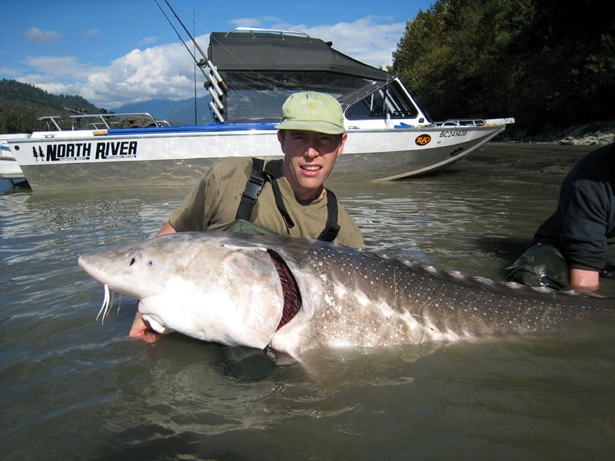
And here’s another fantastic fish – a vast sturgeon taken by Phil. He’s so reticent that he didn’t send any details with the pic, such as weight or location, but I’d give him at least 40lb for it, and I expect it was taken on one of Frank’s amazing cod, tarpon, sturgeon and Nessie trips.

(Before any of you email me saying the boat in the background clearly states “North River, Roseburg, Oregon”, yes I can see that. But how am I going to fit the maximum number of childish jibes into this newsletter if I am restricted to the truth?)

